ECE/COE 1896

Senior Design

Robotic Blackjack Dealer Conceptual Design

Team #7

Prepared By: Kyle Cullen

Nicholas Lowe

Curtis Maher

Luca Mahoney

# Table of Contents

Table of Contents **1**

Table of Figures **4**

Table of Tables **4**

Introduction **1**

Background **1**

System Requirements **4**

Functional Requirements 4

Physical Requirements 4

Dimensions 4

Card Movement 4

Speed and Timing 4

Vacuum Generation 4

Electrical Requirements 5

Motors/Motor Driver 5

Control Modules 5

Software Requirements 5

Device Compatibility 5

Program Language 5

Betting 5

Image Processing 5

Player Input 6

Game Output 6

Interfacing 6

Game Rules 6

Card Values 6

Starting 6

Playing 6

Player Winning 7

Dealer Winning 7

Betting 7

**Design Constraints: Standards and Impacts** **7**

Industry or Government Standards 7

Impacts in Non-Technical Contexts 8

Global, Cultural and Societal 8

Legal Limitations 8

**Conceptual Designs** **8**

Design Concept 1 8

Hardware 8

Primary Mechanism 8

Vacuum Pump 9

Power Supply 10

Motors and Drivers 13

Flipping Mechanism 14

Control Modules 14

Computer Vision 15

Hardware Input/Output 15

Software 16

Image Processing 16

Game Logic 17

Motor Control 18

Design Concept 2 19

Hardware 19

Primary Mechanism 19

Venturi Vacuum Generator 20

Power Supply 20

Motors and Drivers 20

Flipping Mechanism 20

Control Modules 21

Computer Vision 21

Hardware Input/Output 21

Software 21

Image Processing 21

Game Logic 22

Motor Control 22

Selected Design Concept 22

Hardware 22

Primary Mechanism 22

Vacuum Generation 22

Power Supply 22

Motors and Drivers 23

Flipping Mechanism 23

Control Modules 23

Computer Vision 23

Hardware Input/Output 23

Software 23

Image Processing 23

Game Logic 24

Motor Control 24

System Test and Verification **24**

Software Systems 24

Game Logic Tests 24

Computer Vision Tests 24

Hardware Systems 25

Power Supply Tests 25

Gantry System Tests 26

Team **27**

Kyle Cullen 27

Skills learned in ECE coursework 27

Skills learned outside ECE coursework 28

Nicholas Lowe 28

Skills learned in ECE coursework 28

Skills learned outside ECE coursework 29

Curtis Maher 29

Skills learned in ECE coursework 29

Skills learned outside ECE coursework 30

Luca Mahoney 30

Skills learned in ECE coursework 30

Skills learned outside ECE coursework 31

Schedule and Budget Plan **31**

Project Schedule 31

Project Budget 35

Minimum Standard for Project Completion 36

Final Demonstration 36

References **37**

[To update the Table of Contents, Table of Figures, or Table of Tables, click on any text within the table. Press the F9 key on your keyboard (or right click and select “Update Field”). Then select “Update entire table” from the pop-up window and click “OK”. If you use the formatting styles as directed below, your tables will fill automatically and have the correct page numbers.]

# Table of Figures

Figure 1: Yaskawa Motoman Robotics’ Robotic Blackjack Dealer 3

Figure 2: Gantry (top view)9

Figure 3: Gantry (side view) 9

Figure 4: Force Calculations for Card Lifting 10

Figure 5: Pressure Calculations for Card Lifting 10

Figure 6: Transformer to be Used for the Design 11

Figure 7: Wall Plug Connection Attached to the Primary Side of the Transformer’s Lines 11

Figure 8: Schematic of the Transformer’s Design 11

Figure 9: Waveforms of the Open Load Conditions of the Transformer. 11

Figure 10: Waveforms of the Open Load Conditions of the Transformer. 11

Figure 11: LTSpice Schematic of L-section Filter 12

Figure 12: Ripple Factor Calculations 12

Figure 13: Lowest LC Value Required to have a Ripple Output of less than 2% 13

Figure 14: Flowchart for Project’s Electrical Connections 13

Figure 15: CNC Shield with one DRV8825 Motor Controller 14

Figure 16: Raspberry PI 4 Model B Board 15

Figure 17: Arduino Uno Unit 15

Figure 18: Standard Playing Cards 16

Figure 19: Image Processing Flowchart 17

Figure 20: Game Logic Flowchart for a Game of Blackjack 18

Figure 21 : Grbl Controller v3.6.1 19

Figure 22 : Linear Actuator Bundle 20

# Table of Tables

Table 1: Fund Allocation 35

# Introduction

This Robotic Blackjack Dealer project will be designed to provide users with an interactive experience of playing Blackjack that combines the tangibility of playing in real life with the ease of automation found in online games.

The goal of this project will be to design a robotic system that can function as an effective card dealer at a Blackjack table. Currently, live-human dealers are costly for casinos to employ, and hiring enough dealers to fill tables at a casino may increase this cost. Players may also feel uncomfortable with an experienced dealer possibly manipulating the cards to give the house a favorable advantage in the game. Replacing live dealers with robotic dealers will cut on the casinos expenses, allow for more players to be hosted, and will allow for a better established trust that there is no cheating or manipulation

Our design takes influence from 3D printers and a common method with which they navigate a plane. We’ll have a gantry setup that is fixed on a table top and covers an x-y plane. Within the center arm of the gantry, will be a vertically mounted component that can move along the z-axis with a vacuum pump to enable the picking up and movement of cards around the table. Beneath the table will be a camera and connected Raspberry Pi, with the camera looking vertically through a piece of clear acrylic. Also connected to the Pi will be a touchscreen display to enable player interactivity, as well as an Arduino Uno which will handle commands from the Pi and output controls to the motors driving the system.

The final product will function as a blackjack dealer that could easily replace a human at a table. The system’s hardware will include a device that can function as an “arm” and will move a “hand” to move cards around the table. To know what cards are being played, the system’s camera can take a picture of cards as they are being dealt. With this input, the software side of the system will interpret the current state of the game and then prompt the player(s) for their input, which would then further continue the flow of the game’s algorithm. The game as a whole will follow a standard Blackjack ruleset and will incorporate the ability to have multiple players, each able to place bets.

# Background

Blackjack (also known as 21 and pontoon) is a card game played around the world. While its origin is disputed and house rules vary, the general concept of the game remains the same: try to get your hand closer to 21 than the dealer without going over 21. You can add cards to your initial hand of two by requesting a ‘hit’ from the dealer and can choose to ‘stand’ once you feel confident that your hand can win, given that you do so before you go over 21 (‘bust’). This simple concept has stood the test of time as a fun and engaging game of chance and is still a staple in the gambling world to this day.

Blackjack utilizes the standard deck of playing cards, which consists of 52 unique cards. There are 13 different card values, 9 of which are numbered 2-10, respectively. There are 3 face cards: the Jack, the Queen, and the King. Finally, there is the Ace, which typically takes on unique roles in card games, as it can either represent 1 or 11. Each card also has a specified suit, which include hearts, diamonds, spades, and clubs. Hearts and diamonds are typically colored red, with black as the primary color for clubs and spades. There are 4 cards each for the 13 different values, so that each card has a unique value and suit combination. Suit is ignored in blackjack, so the value is the only relevant identifier for this game.

One of the biggest reasons why Blackjack has persisted through the years is that it has a low barrier to entry. Casinos use this ease of access to their advantage by lulling confident players to a game stacked against their favor.

From the beginning of a hand of Blackjack, the player is at a disadvantage, due to the order of play that Blackjack usually takes. The dealer, in most variations of Blackjack, is the last to play among the table. This gives every player playing against the dealer a chance to ‘bust’ before the dealer.

Another common tactic used by casinos to stack the odds against the player is the use of multiple decks in a single game. In single deck Blackjack with a $3 to $2 payout (using standard hand rules), the player has the advantage over the dealer, given a large number of hands being played. But with each consecutive deck added to the game, the complexity of the hands grows, and the advantage starkly shifts to that of the dealer. For example, the average payout in a single deck game of Blackjack using the rules described above should be slightly in your favor with the player winning .02427% of what they wager. However, with a two-deck game using the same rules, the dealer would have an average return of .348% of the player's wager, with each consecutive deck moving the advantage further and further to the dealer[1].

All the tactics used by casinos in Blackjack and other games have led to players having a serious distrust of human dealers and for casinos to have a bad reputation in general. Many believe that casinos not only stack games against them in structure, but actively cheat them to get even more of their money. These feelings of distrust have led to players moving to electronic means of playing the games, mostly on gambling websites or through mobile apps. At the cost of removing the social and aesthetic aspects of a traditional casino, players feel more at ease that a slight of hand will not be the reason they lose money.

What we are attempting to do with our project is bridge the gap between the in-person aspect of the traditional game of Blackjack and the trust that many players have with electronic versions of the game by creating a Blackjack table where there is no human dealer. Instead, players will play the game with a robotic Blackjack dealer.

If the human Blackjack dealer is removed, there is potential for additional financial gain for the casino. The average casino dealer earns about $38,434 annually, averaging to about $739 a week [2]. The prototype that we are developing will cost approximately $200. Even with manufacturing fees and maintenance fees, the robotic dealer would save casinos thousands of dollars. For a smaller end casino that has a limited budget, this device would provide a low cost alternative to hiring several human dealers. Due to the lower cost of the dealer, the casino could implement several robotic dealers for the cost of one human dealer. This would allow the casino to spend more elsewhere, improving the overall environment of the casino and the experience for the customers.

Another benefit that the robotic Blackjack dealer could provide is the removal of tips for the dealer. Casino etiquette states that you should tip your dealer 15-20% of the amount you buy in with [3]. If the obligation to tip your dealer is removed, then the average customer will have 15-20% more spendable money, which could go straight to the casino in forms of food, drink, or more bets. The casino not only saves money with the robotic dealer, but has the chance to increase income even more by encouraging their customers to spend more.

A robotic dealer will also be able to work for as many hours as needed without a break. They are also not subject to overtime pay, so the potential savings would further increase if the casino’s human dealers typically work more than 40 hours a week[4].

There are several existing solutions to automating Blackjack. The most popular is virtual casinos. There are two types of virtual casinos, which are RNG based and live dealer based. Several online sportsbooks have both, and they each have their strengths and weaknesses. The RNG based version is fully virtual, where a computer program is using RNG to decide which cards are dealt. However, the lack of trust towards a human dealer should carry over to a program written by the casino, because one may believe the program is purposefully dealing with losing cards based on the game situation.

The other type of virtual casino utilizes a live dealer, where the customer plays remotely, and a human dealer livestreams the results of the hand. This solution does not fix either problem presented, as a customer may still distrust the human dealer, and the casino still is required to pay the human dealer. Virtual casinos may also turn out to be a scam, as there are fewer barriers to entry to set up a website than there are to establish a casino[5].

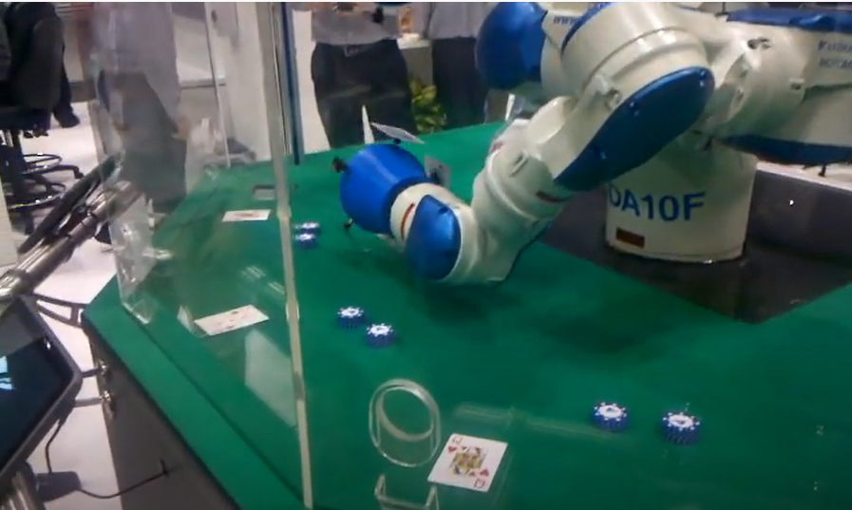

Figure 1: Yaskawa Motoman Robotics’ Robotic Blackjack Dealer [6]

Several projects implementing the robotic Blackjack dealer have been executed before. At Automate 2013, which is a convention to display advances in automation, Yaskawa Motoman Robotics debuted their robotic Blackjack dealer[6]. The humanoid dealer spins its arms, picking up cards one at a time using suction cups. The dealer uses a camera to read each card and uses computer vision to decipher each card, and each customer has a tablet that displays their current game situation. Our design improves off this design by greatly minimizing the costs. A device, like the one shown in figure 1, utilizes Motoman robotics, and the low end price for a second hand robot, which is worse than the one in figure 1, costs anywhere from $17,500 to $35,000 [7]. This price far exceeds the estimated cost of $200 for our prototype, and this solution fails because it does not solve the financial constraint for a casino.

# System Requirements

## Functional Requirements

### Physical Requirements

#### Dimensions

* The entire system should be able to fit on a tabletop and accommodate three players.
* The card moving mechanism should have a minimum clearance of 6” to allow room for the card drawing and flipping mechanisms.
* The playing surface should have a maximum clearance of 12” above the surface of the table. This will allow for both camera distancing and a compartment for component placement out of player view.
* The cards should be within 8” and 12” from the camera for the camera to read them.

#### Card Movement

* Cards shall be moved to predetermined locations from a starting location of the deck. These locations include a spot for the dealer’s cards, a discard pile, and evenly spaced spots for each player’s cards. Exact locations will be determined in development, however, with the defined location (the size of a standard playing card), there will be an allowed tolerance of +/- 0.5” from each edge of the designated area. This tolerance will also apply to overall drift over three games.

#### Speed and Timing

* The initial deal process should take no more than 1 minute.
* A game of blackjack shall be completed in a reasonable period of time. To roughly approximate this, the total time should be less than or equal to one minute times the number of players, including the dealer, plus one minute for the deal. E.g. a 2 player game shall complete in 4 minutes.

#### **Vacuum Generation**

* The vacuum system shall be capable of generating a lifting force to hold a single, standard playing card during gantry movement. A single card weighs approximately 96 grams.

### Electrical Requirements

#### **Motors/Motor Driver**

* NEMA 17 stepper motors operate between 12V to 36V and have a maximum current of 1.7A.
* Vacuum pump operates between 1.5V and 5V with a maximum current of .5A.
* DRV8825 motor driver requires 5V with a maximum current of 2.5A to motors.

#### Control Modules

* Arduino Uno operates between 2.5V to 5V with an average current draw of 50mA.
* Raspberry PI 4 Module B requires 5V with an average current draw of around 900mA.

### Software Requirements

#### Device Compatibility

* The main program with the game algorithm and image processing shall run on a Raspberry Pi.
* The secondary program, for motor controls shall be flashed onto and run from an Arduino Uno.

#### Program Language

* The main program with the game algorithm and image processing shall be written in Python.
* The secondary program, for motor controls, shall be written in C++. This will utilize a specialized version of grbl for this project’s gantry control and be stored in an Arduino Uno.
* Movements will be coded and stored in the Raspberry Pi as text and transferred at need to the Arduino Uno.

#### Betting

* The system shall allow players to “deposit” money for a starting balance through the touchscreen display input interface via a ‘deposit’ button at the start of a game.
* The system shall allow players to place bets through the touchscreen display input interface via the press of a ‘bet’ button.
* If a player’s bet wins, the system shall provide them with the winnings. On the contrary, if a player loses, the system shall collect the losing bet.

#### Image Processing

* The system shall have a method to process an image of a playing card and produce the accurate value and suit of the card.
* The system shall be able to communicate this value as an input for the game algorithm module.
* The runtime for the method shall be within 5 seconds.
* The accuracy for the method shall be greater than 99%.

#### Player Input

* The system shall have a method for the users to input into the system via tangible buttons or touchscreen buttons. These inputs will be for playing commands such as ‘hit’ or ‘stand’, as well as for wagering throughout the game.

#### Game Output

* The current state of the game shall be visible to the players at all times via a single display screen used for all players.
* When a user’s input is required, it shall be made very clear which player is responsible by showing a player number as well as the current hand.

#### Interfacing

* The Raspberry Pi shall be able to connect to and communicate with an external Arduino ATMega-style chip. This will be achieved via serial communication at a baud rate of 115200.

## Game Rules

The game shall have a standard Blackjack ruleset. This is defined below and is referenced from the ruleset used at *Hollywood Casino at The Meadows* [8]. No matter the number of players at the table, each player will only be playing against the dealer and not any other players.

### Card Values

* Numbered cards will have a value equal to their face value with the exception of the ace, which can have a value of either 1 or 11.
* If a player should bust due to a high ace, the ace's value is treated as the lower value (I.E. if the dealer draws 8 after a starting hand of an ace and a 3, the value of the dealer's hand is then calculated as 12 rather than 22).
* All face cards will have a value of 10.

### Starting

* Dealer begins the round by giving a single, face-up card to each player.
* Dealer then gives each player a face down card that only the respective player may know about.
* Players may split their hands into two individual hands if their starting hand has two identical card values. A player will receive two additional cards if they choose to split their hand: one for each hand they have for the round. Split hands require their own bet.

### Playing

* Sequentially, each player can request an additional card as many times as they choose (given they do not ‘bust’) by choosing to hit.
* When a player does not want any more cards, they can request to ‘stand’, in which case, the next player can ‘hit’ as many times as they choose.
* This process is continued until each player has had a chance to ‘hit’. After that, the dealer then begins drawing cards until they win (see player winning) or ‘bust’.

### Player Winning

* If the player’s hand equals 21, then they automatically win the round, regardless of the dealer's hand at the end of the round.
* If the player’s hand is more than the dealer’s hand before the dealer bust, then the player wins the round.

### Dealer Winning

* If the dealer’s hand equals 21, then they automatically win the round, given the player did not already reach Blackjack.
* If the player goes over 21 after a hit, then the dealer wins.

### Betting

* The minimum for each player is 1 unit.
* When the dealer’s face up card is an ace, each player has the opportunity to place an insurance bet, in which they bet on if the dealer's next card will bring their hand to 21.
* All winning bets will return the initial wager, plus an additional value equal to the wager returned. Contrarily, all losing bets will return 0 units.
* At any point, a player can ‘double down’, which doubles their current wager and deals one more card before forcing the player to stand if the extra card does put their hand above 21.
* At any point, a player can ‘surrender’ which concedes the game to the dealer and return half of the player’s wager to the player

# Design Constraints: Standards and Impacts

## Industry or Government Standards

Our final design will comply with FCC, OSHA, and UL standards regarding radio frequency communications, unguarded voltage protections, and transformer safety respectively. These standards are to be employed in our project to ensure a lack of interference between external systems and to prioritize the safety of any operators of our project.

The FCC standards concerned with our project are found in Part 15 of the FCC rules and regulations regarding operating frequency and interference. All the modules used in our project comply with the FCCs regulations regarding radio frequencies produced by digital switching logic and interference conformity and are being used within those acceptable ranges specified by the FCC standard [9].

The OSHA standards our team focused on meeting was Occupational Health and Safety standard 1910.303(g)(2)(i)(A) - (D), 1910.303(g)(2)(ii), and 1910.303(g)(2)(iii). These standards concern the level and accessibility of electrical equipment operating at or exceeding 50V. As the source of power for our design is by AC-DC conversion from a standard wall outlet, a sturdy and insulated enclosure for the system’s transformer is a necessity [10].

The final major standard our team focused on was concerned with the UL standards for transformers and power supply systems. These standards are a means of ‘recognizing’ transformers or other high-voltage, power electronics as safe and consistent in its construction. Though our transformer was sourced from secondary sources, it is still listed as being a UL recognized device. As this UL recognized transformer is being used in a proper manner (within primary rating, not being used in reverse, etc.) our project follows the UL standards for transformers [11].

## Impacts in Non-Technical Contexts

### Global, Cultural and Societal

Our project’s major impacts in a cultural/societal context are focused within the context of entertainment. This project could exist in places of entertainment or as a home product used at social gatherings or events and would be a novel means of playing a classic card game. As the basis of the game is a simple game of chance and is only related to gambling when a betting system is implemented, the concept could also be included in educational settings as a potential introduction to or an entertaining means of presenting probability and statistics to students.

### Legal Limitations

Gambling is defined and enforced differently for each state across the country. To ensure that we are not struck with charges for disobeying any gambling laws, this system will be designed without the feature of including real currency. To ensure we are not labeled as a ‘casino’ or other ‘gaming entity’, and to avoid requesting a license or permit from the PA Gaming Control Board for our activities, the wagering in our game will be with units that do not have any monetary value and will not require any cost to obtain. Additionally, the odds of winning will be truly random and there will be no ‘house edge’ or ‘house favor’ to give players the fairest chance for winning.

# Conceptual Designs

## Design Concept 1

### Hardware

#### Primary Mechanism

The primary hardware mechanism for this design will be based around a gantry model. Similar to the way a 3D printer might work, this gantry will have beams surrounding the play area with a beam in the middle that holds the card moving mechanism. This middle beam will be moved around via two servo motors positioned at the corners of the gantry and that utilize a series of belts that are tied to the cross-beam. This belt system will follow a CoreXY design to ensure that both servo motors that drive the system will remain stationary as the cross-beam moves around [12].

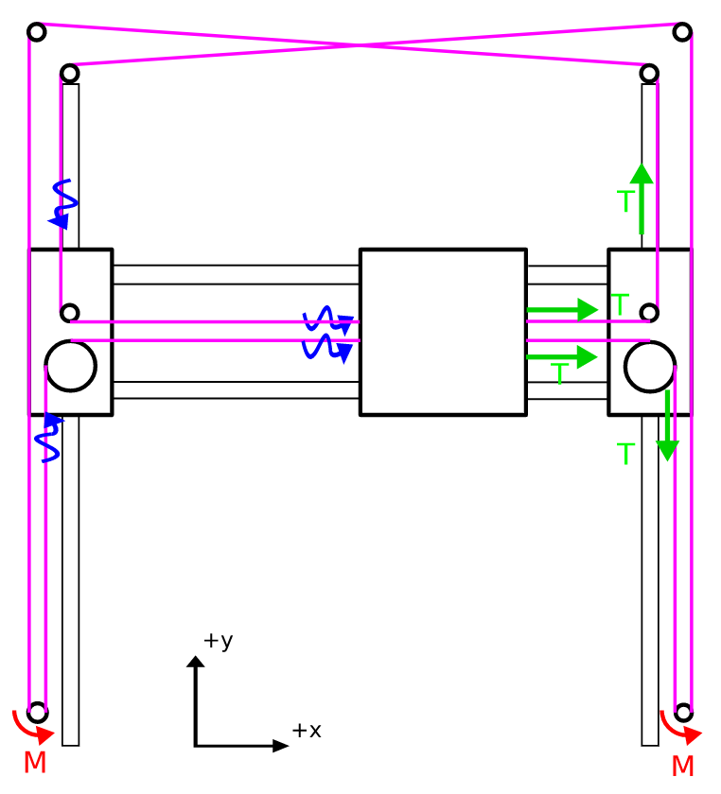

Figure 2: Gantry (top view)

Upon the middle cross beam, there will be a third servo motor responsible for moving a mechanism vertically on the beam. The mechanism will have a vacuum pump with the suction piece positioned at the bottom. As the servo motor runs, this pump will move up and down above the surface of the table. When the pump is lowered, it will also be activated, and when it is positioned onto a playing card the suction effect will pick up a single card and keep a hold of it to allow for movement around the table.

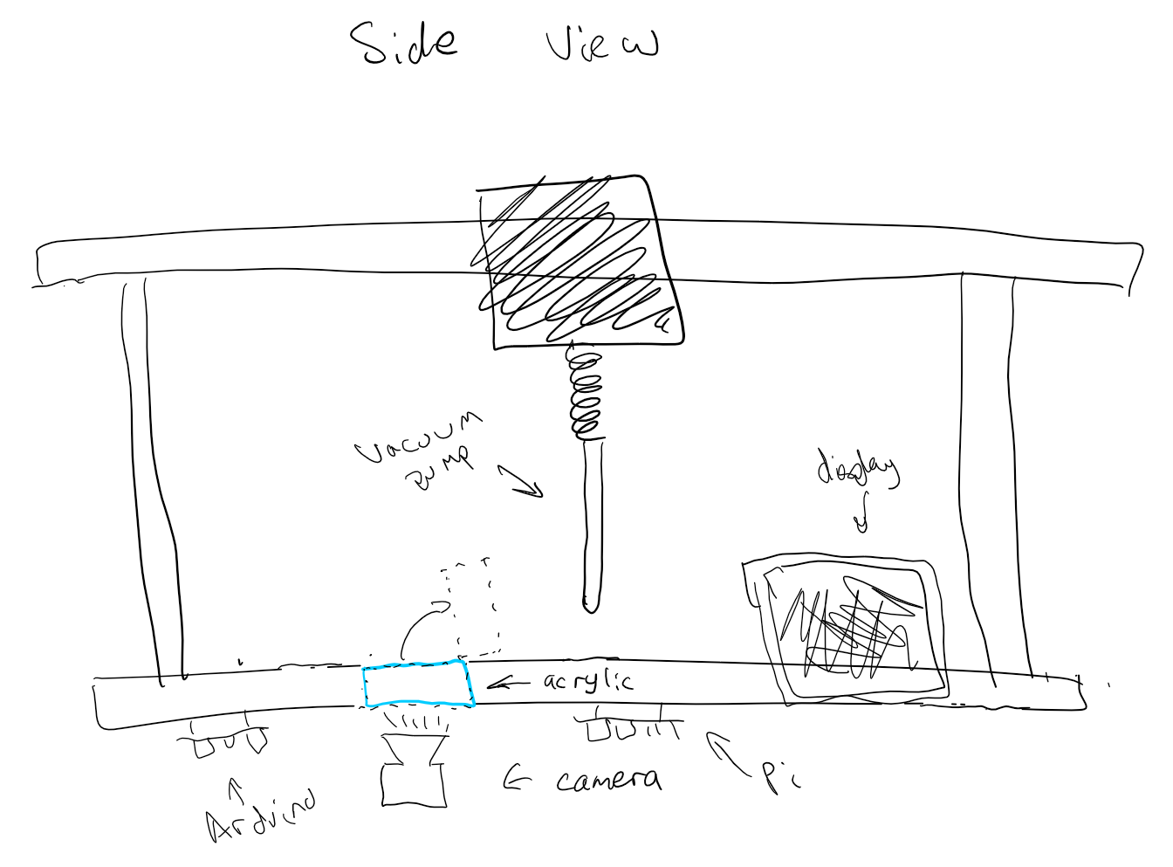

Figure 3: Gantry (side view)

#### **Vacuum Pump**

For our design, our vacuum pump must be able to generate enough negative pressure at its output to lift a standard playing card. Given that a standard playing card weighs about 96 grams, the amount of force required to lift a single card can be calculated by:

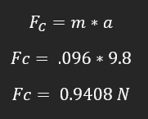

Figure 4: Force Calculations for Card Lifting

This means that our pump will need to be able to create a negative pressure that will generate a force greater than .9408 N to lift the playing card into the air (neglecting air resistance inherent to lifting the card at a given speed). The pressure required to achieve this feat is dependent on the area from which the force is being applied, which can vary from product to product. To that end, the calculation below are to determine the amount of pressure necessary to lift a playing card given that the aperture from which the air pressure is generated is 4.3mm in diameter (the same diameter as our initial pump):

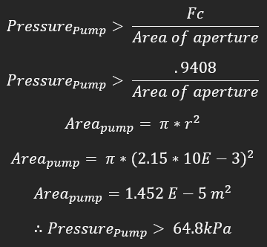

Figure 5: Pressure Calculations for Card Lifting (assuming 4.3mm aperture)

#### **Power Supply**

As stated before, we plan to use a standard wall outlet with an AC-DC conversion circuit to get the required voltage levels for our system. Our transformer is a Hammond 165P30 center tap, step down, 115V:30 V 5A unit that will have its output fed into an L-section filter. Below is an image of the transformer, its schematic, and images depicting the no-load voltage across its output terminals:

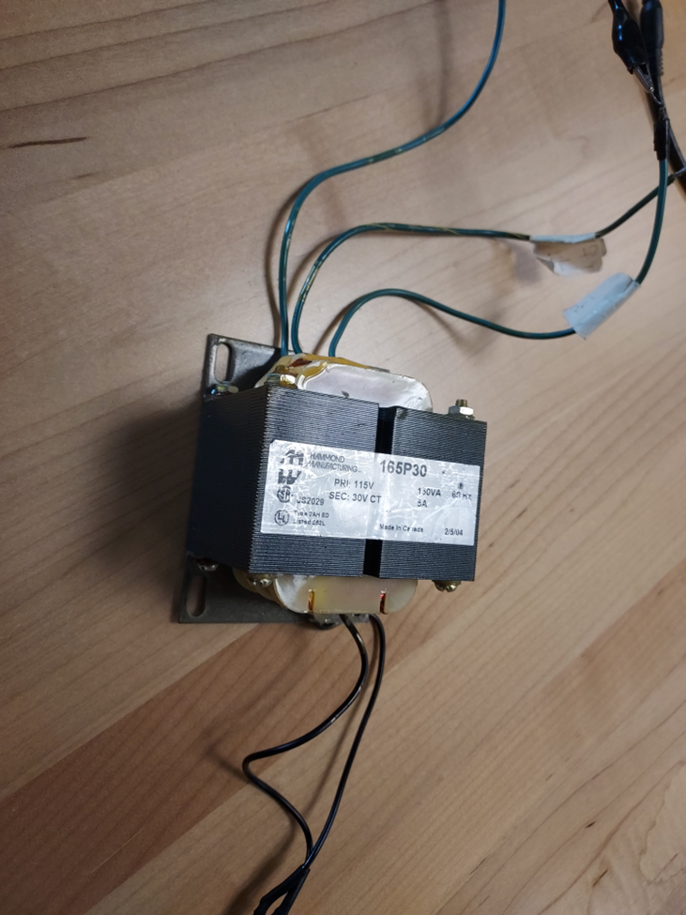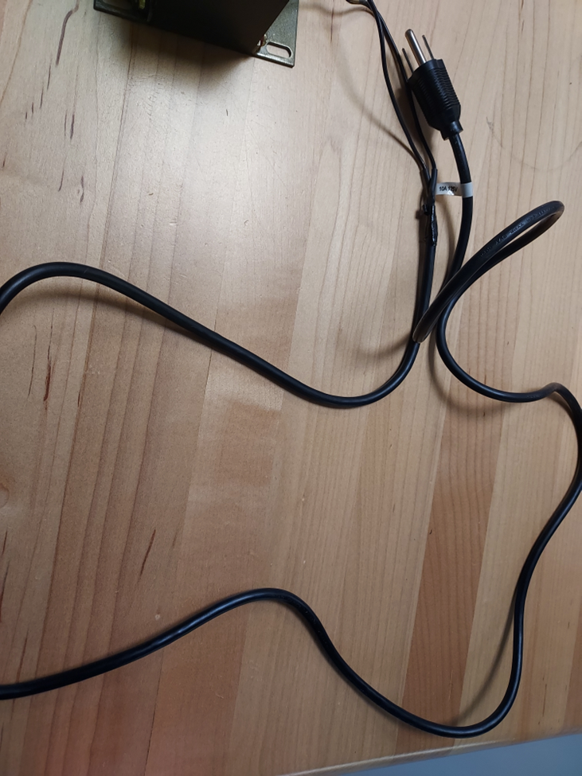

Figure 6:(left) Transformer to be Used for the Design

Figure 7: (right): Wall Plug Connection Attached to the Primary Side of the Transformer’s Lines

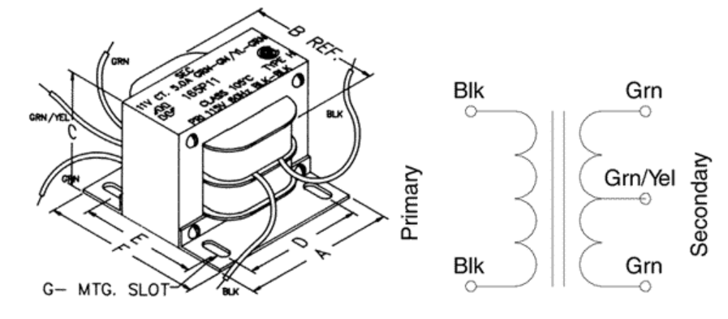

Figure 8: Schematic of the Transformer’s Design. The green/yellow wire indicates the center tap of the transformer, off which we could use to power the smaller components so as not to waste power burnt off in regulation. [11]

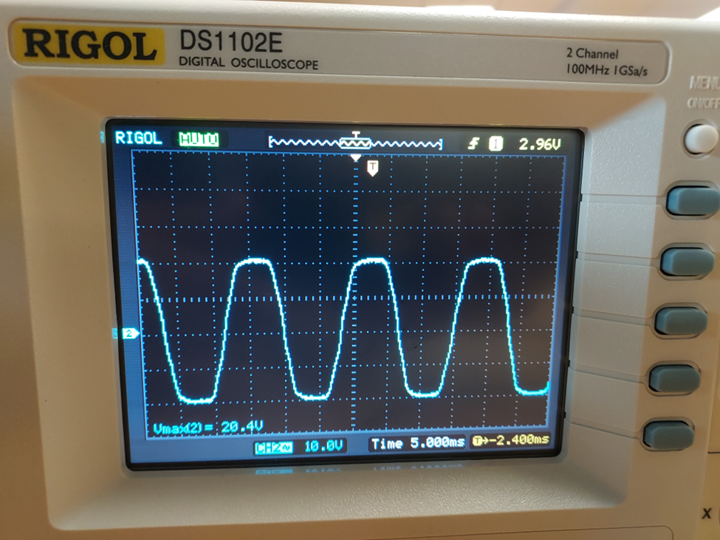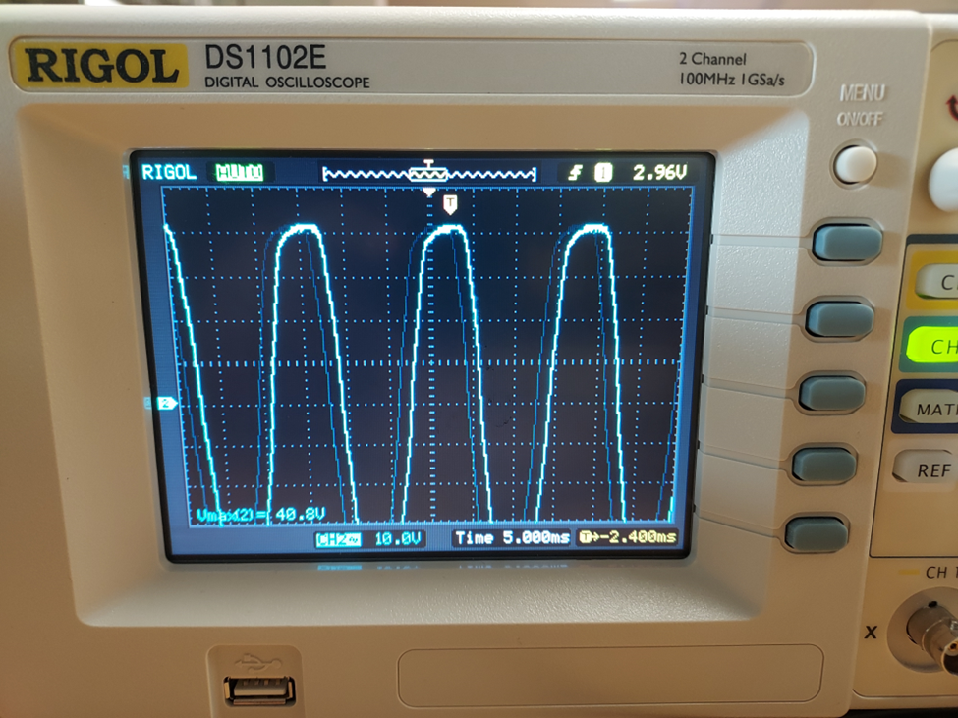

Figures 9 and 10: Waveforms of the Open Load Conditions of the Transformer. The left image uses the center tap of the transformer while the right uses both ends of the transformer. Both experience minor saturation.

The filter for the AC-DC rectifier will be an L-section filter. This filter was chosen to ensure better filtration compared to a purely inductive or capacitive filter and to ensure minimum changes in the output voltage corresponding to changes in current draw. Since we will be operating several motors off of the power supply (each taking around 1.7A), our filter needs to be resilient to changes in current draw so that any changes due to motor operation do not affect the output voltage. This filter will accomplish this by inductively coupling the DC portions of the signal while simultaneously preventing abrupt changes in the voltage using the relation of V = L di/dt. Below is a schematic of the filter:

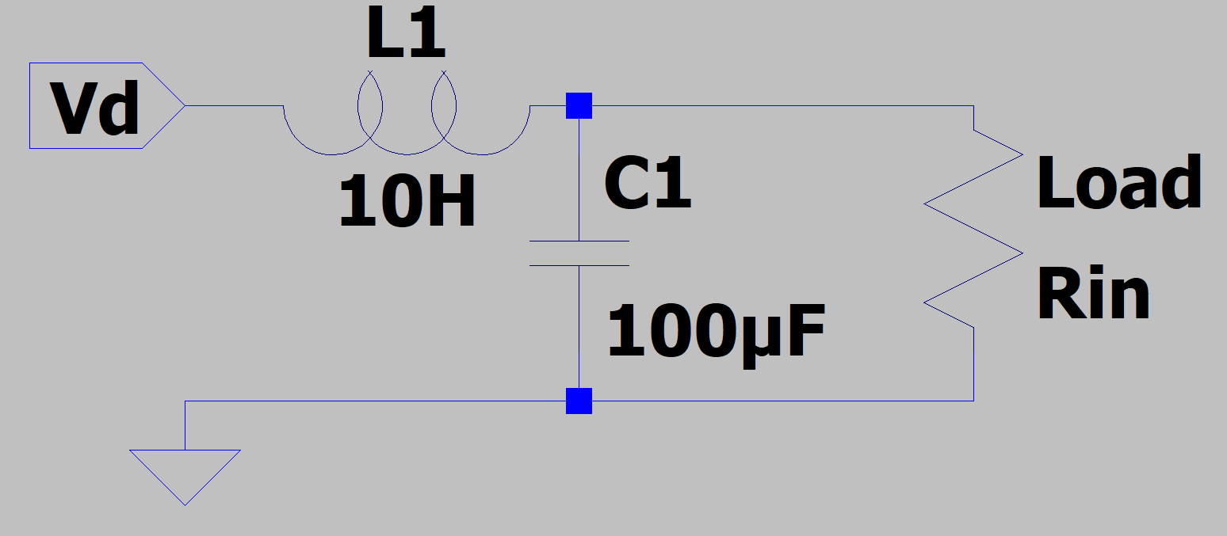

Figure 11: LTSpice Schematic of L-section Filter

One key aspect for concern in filtering the output is to ensure that the ripple factor inherent to all AC-DC conversion circuits is minimized. For the purposes of this project, the limit for ripple in our system will be a 2% AC component in the DC signal. The ripple factor is a ratio between the AC components (rms) to the DC component of the output and varies in calculation from filter to filter.. For an L-section filter, the ripple factor is given as [13]:

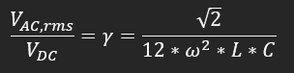

Figure 12: Ripple Factor Calculations

So, to determine the optimal values to meet this threshold, the ripple factor was set to .02 to determine the highest value of LC that could be used while maintaining a ripple of .02. Below are the calculations for the highest value of LC that could be used:

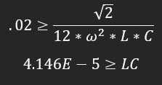

Figure 13: Lowest LC Value Required to have a Ripple Output of less than 2%

The rectified voltage will then be fed to two regulation circuits: one for 5V and one for 30V. Our 5V regulator will power the control modules (Raspberry Pi and Arduino Uno), Vacuum tube, and motor drivers while the 30V supply will be the input to our stepper motors. Below is a flowchart to show the electrical connections that will be made in the completed circuit:

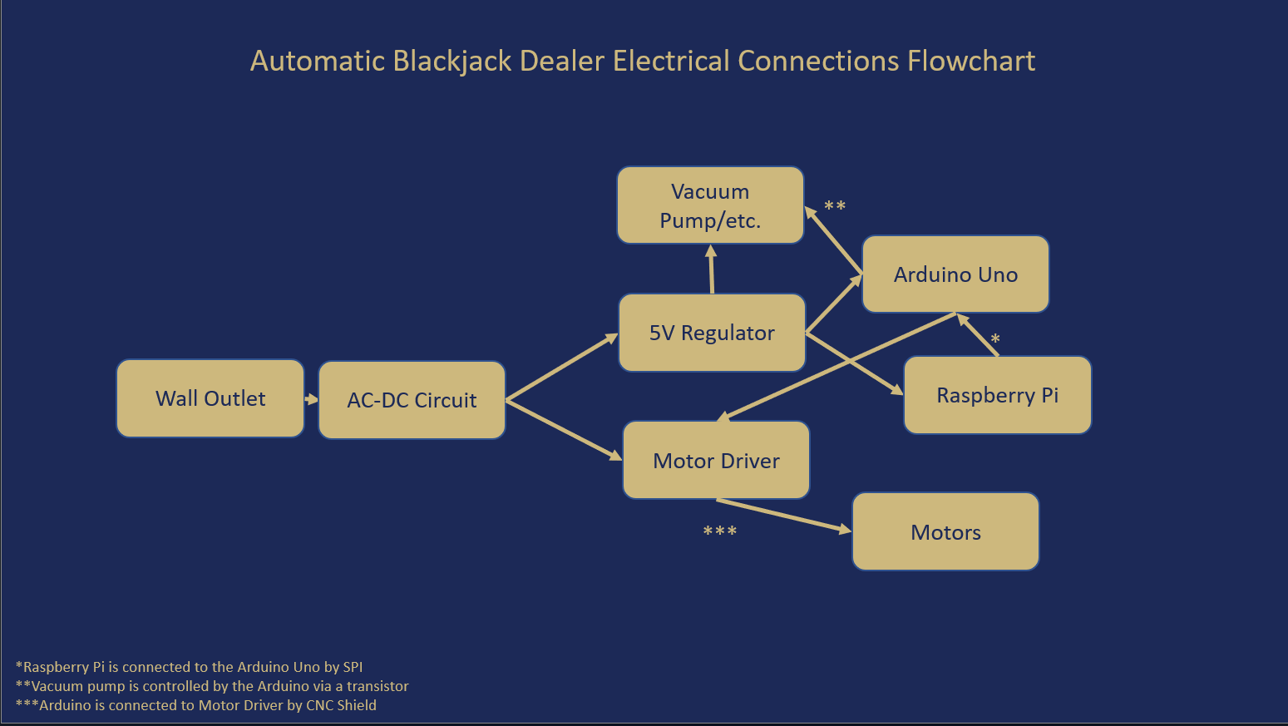

Figure 14: Flowchart for Project’s Electrical Connections

Because our power supply will conduct high voltage on the primary side, a containment unit will be necessary to ensure the safety of anyone interacting with our project. To that end, an acrylic containment unit will be constructed to contain our transformer while our wires will be properly insulated to minimize any potential for electric shock.

#### **Motors and Drivers**

The design will employ 3 2-pole NEMA 17 motors and vacuum pump. The NEMA motors operate between 10V and 36V with a maximum current draw of 1.7A on either pole, while the vacuum pump operates between 1.5V and 5V with a maximum current draw of .5A.

To control the NEMA motors, we plan to use the DRV8825 motor driver. Each driver will control one motor through PWM on an H-bridge inverter’s transistors and will limit current into each motor using an onboard foldback current limiting circuit to prevent damage to the motors in the case of a current draw over 1.7A. The DRV8825 motor drivers will connect to a CNC shield to properly route connections from the Arduino Uno to the drivers.

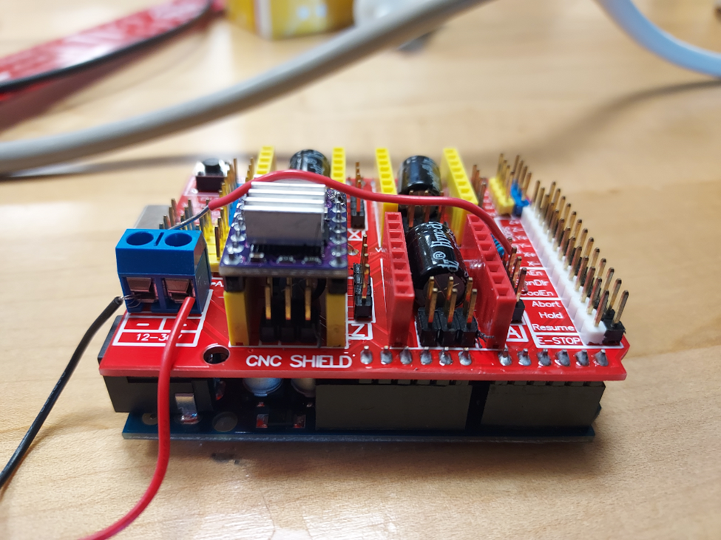

Figure 15: CNC Shield with one DRV8825 Motor Controller. A motor management/protection unit that connects to the top of the Arduino Uno. Can control up to 4 motors at a time.

The vacuum pump will be controlled by a transistor bridging the pump windings and the DC-DC converter output. The transistor will be controlled by a digital output on the Arduino Uno. This setup will allow for an adequate current draw for the motor compared to the Uno’s analog output.

#### Flipping Mechanism

Within the surface of the table, there will be a cutout from the table that will hold a piece of transparent acrylic. This same piece will attach to a servo motor that will allow it to tilt upwards. The function of this will be to flip cards. To decrease the possibility of unexpected movement from the card, the acrylic will have etching and/or a lip at the bottom edge. Adjacent to this flipping mechanism is where the stack of shuffled cards will be placed.

#### Control Modules

The entire system will be designed to run on a combination of a Raspberry Pi 4 and an Arduino Uno. The Pi will harbor the logic for running the game and controlling inputs and outputs, while the Arduino will receive commands from the Pi and translate those into controls for moving motors within the system.

Our control modules will both require 5V to power. This 5V supply will come from a small regulation circuit employing a 5V DC-DC converter to step the voltage down to step the voltage down from 30V to a more manageable 5V. The Arduino Uno will typically require around 55mA of current, while the Raspberry PI will typically draw 910mA.

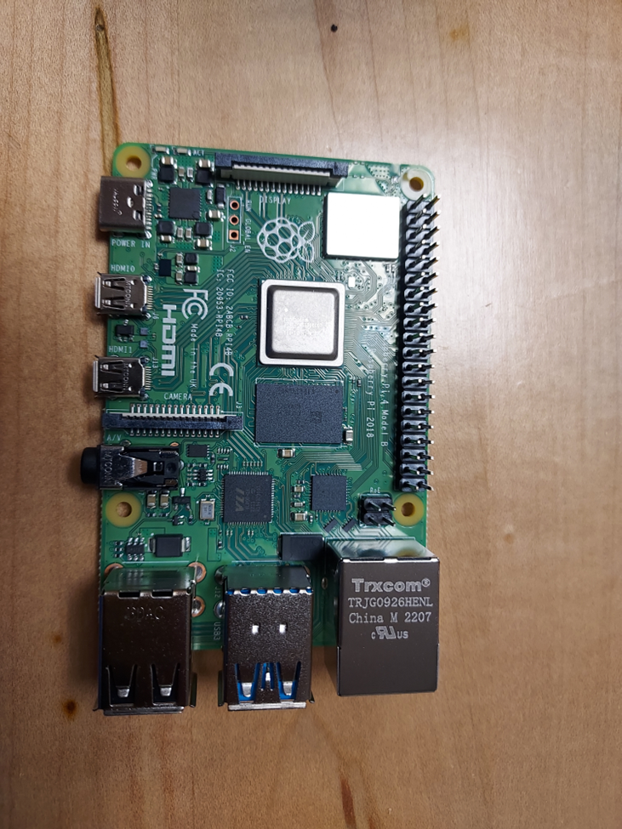

Figure 16: Raspberry PI 4 Model B Board. The focal point for the management of our modules.

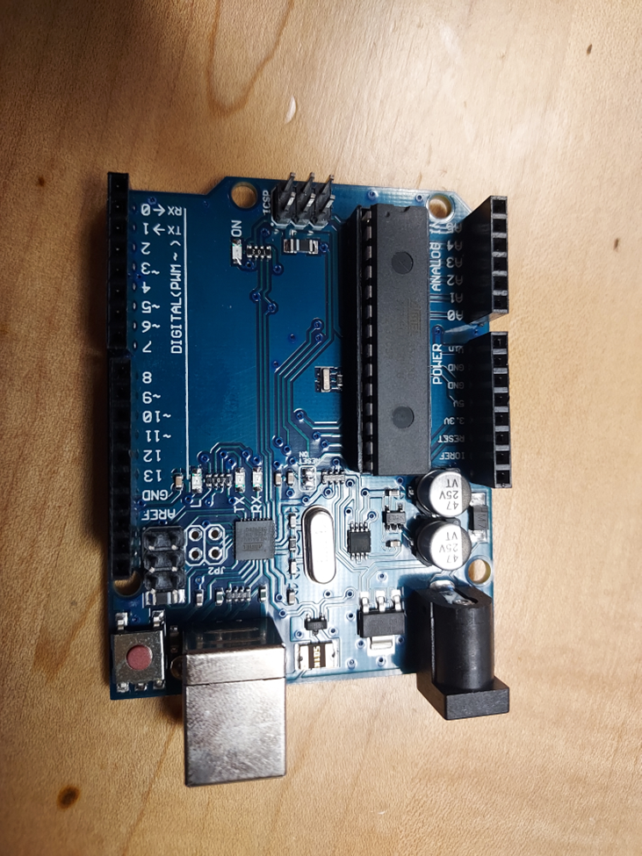

Figure 17: Arduino Uno Unit. This board will control the motors through a CNC shield that attaches to the top of the unit.

#### Computer Vision

Beneath the flipping mechanism is where a camera will be positioned, facing upwards through the acrylic in the table. As cards are placed onto and/or passed over this, the camera will be able to take a picture to then be processed. This camera will be directly connected to the Raspberry Pi.

#### Hardware Input/Output

The Raspberry Pi will interface with an Arduino Uno to communicate commands to the gantry based on the game logic. The Arduino will interface with three separate servos via a CNC shield to control gantry motion in the XY-plane and the vertical position of the vacuum mechanism.

The player will interface with the game through a touchscreen. This screen connected to the Raspberry Pi will provide output information to the user and when the user is prompted, it will read in user input from the screen.

### Software

#### Image Processing

The image processing required for this proposal is to receive an image of an eligible playing card as an input, and to produce the value of this card. This module will be programmed in Python. The camera will take a picture of the card, and the top left corner of the card will be analyzed.

The module will receive this image as an input in a .jpg format. The top left corner of the card, which contains both the value of the card and the suit of the card, is the portion of the card that will be looked at. The rest of the card does not add any information other than visual appeal, so it will be ignored.



Figure 18: Standard Playing Cards [14]

This concept is seen in Figure X, where all of the information needed to determine the identity of the card is located in each corner. Not all brands of cards have the identifier in all four corners, but all standard brands at least have a top left corner identifier.

These symbols will be extracted and through the module, will be compared to pre-loaded images to properly identify the identity of the card. Once complete, the number and suit will be outputted to the game logic module, which will store each of these outputs as current cards in play. A flowchart of the hardware connections required for this module and a basic representation of the flow of the image processing module is shown below in Figure 19.

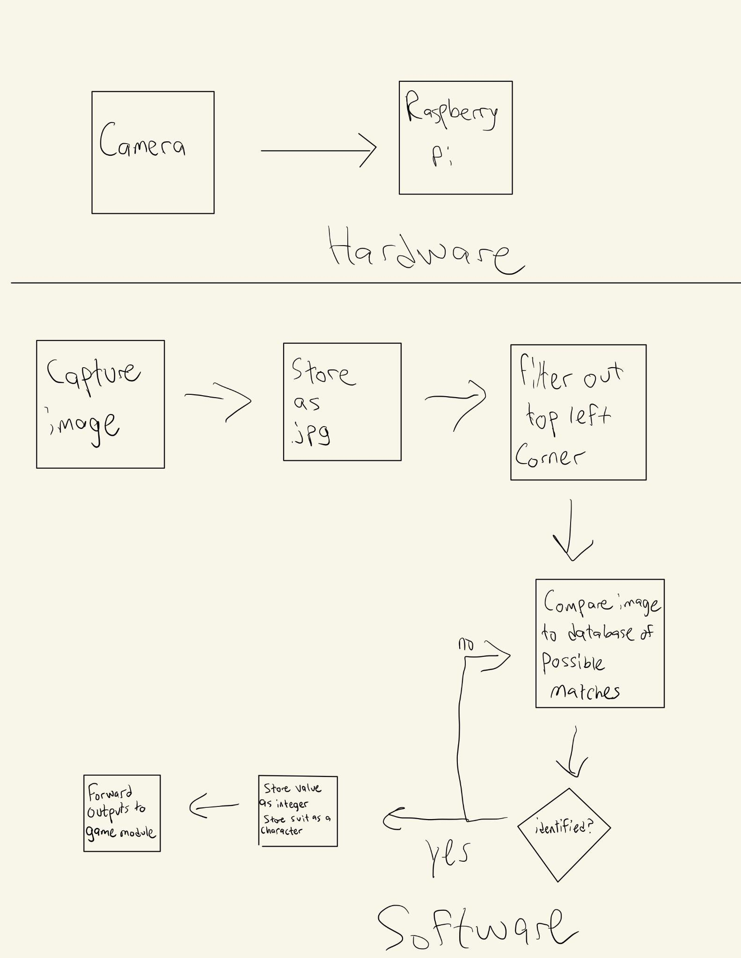

Figure 19: Image Processing Flowchart

#### Game Logic

The game will be designed around a standard Blackjack ruleset. Programmed in Python, the game’s algorithm will be designed using object-oriented programming to treat objects such as cards, hands, players, dealers, etc. as exclusive entities so that they can be handled correctly. Within each of these objects, they will have values and methods exclusive to themselves that allow them to be created, destroyed, and manipulated throughout the game as players play.

Inputs from the touchscreen will be polled in discrete time intervals when the dealer prompts a player for an action. Alternatively, select inputs from the touchscreen will be treated as interrupts, such as adding players, quitting or restarting the game, shutting down the entire system, or displaying an error mode or debug mode to demonstrate what may not be seen on the surface by the user. A basic representation of the gameplay is shown below in Figure 20.

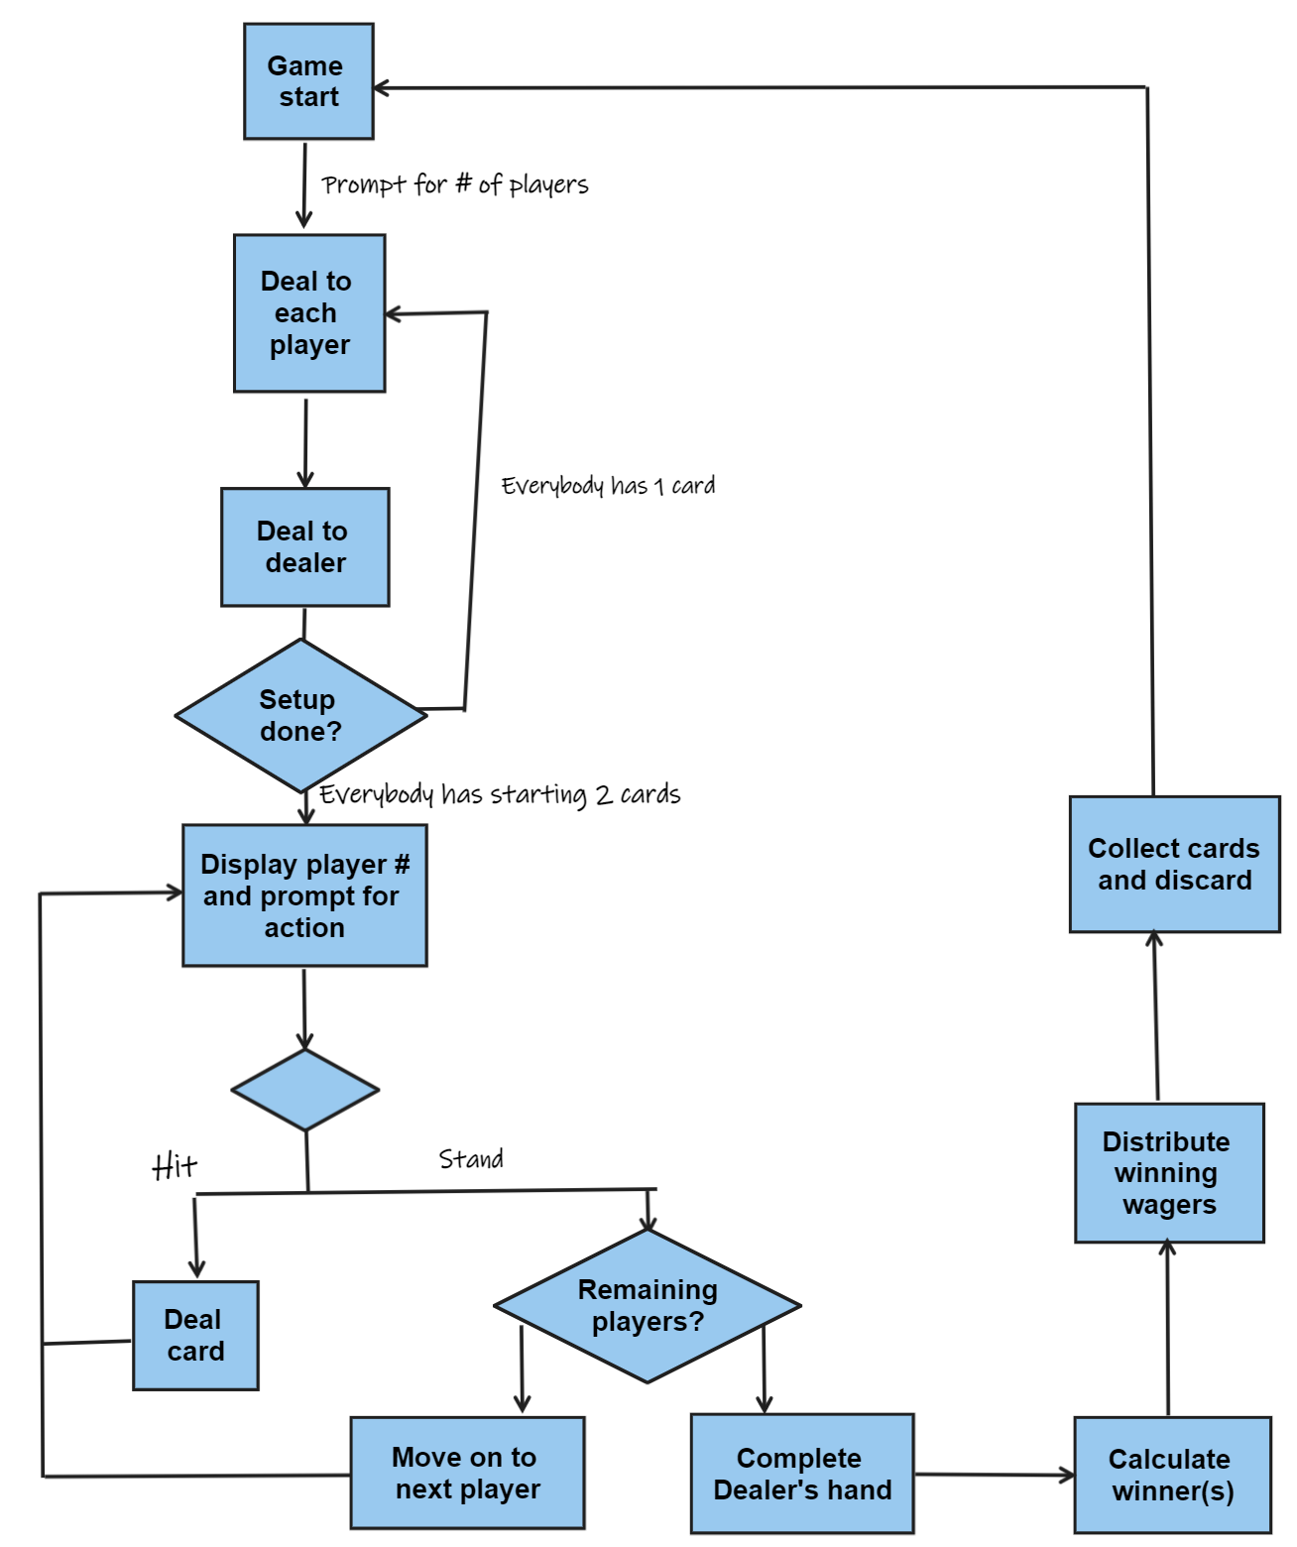

Figure 20: Game Logic Flowchart for a Game of Blackjack

#### Motor Control

For a gantry system such as the one proposed, GRBL is an open source, readily available method of programming that is widely used in DIY CNC machines. This will be the method of control used. Once compiled and uploaded, gantry control is implemented using “g-codes” to move to software defined locations [15]. The source code will need to be modified in line with the size and accessible area of the play area and hardware limitations. This will be originally accomplished using a GRBL controller interface like that below.

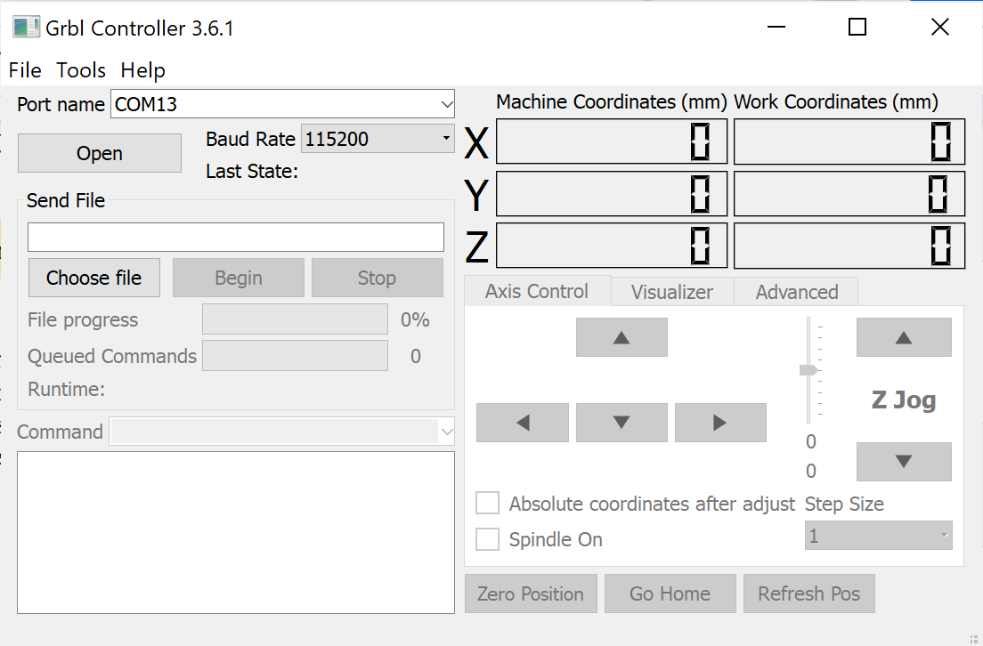

Figure 21 : Grbl Controller v3.6.1

GRBL works in the cartesian coordinate system and would allow command files to be stored as text to complete various commands. As an example, if the game logic requires the gantry to deal player one’s first card, it would feed instructions from file “dealcard1toplayer1.txt” to the arduino line by line:

G00 X0 Y0 //G00 is a rapid positioning command. The gantry will move to position (0,0,0) as quickly as it can (this would be the location for card pick up).

G01 X0 Y0 Z-1 F200 //G01 is a linear interpolation command. The gantry will move to position (0,0,-1) in a straight line from its current position (0,0,0) at a speed of 200 (this would be a move to lower the vacuum tube to the card).

G01 X0 Y50 Z0 F400 // This command will relocate to drop the card in front of player one, etc.

Commands will continue until the full move is complete. In this manner, files for each movement will be developed in conjunction with the game logic to allow for a full game.

## Design Concept 2

### Hardware

#### **Primary Mechanism**

As an alternative primary mechanism, a pedestal mounted linear drive system would be utilized for card placement. This design would operate less like a 3D printer and more like a robotic arm in a polar coordinate system. The below linear drive with gantry plate would be an example of the mechanism for radial motion:

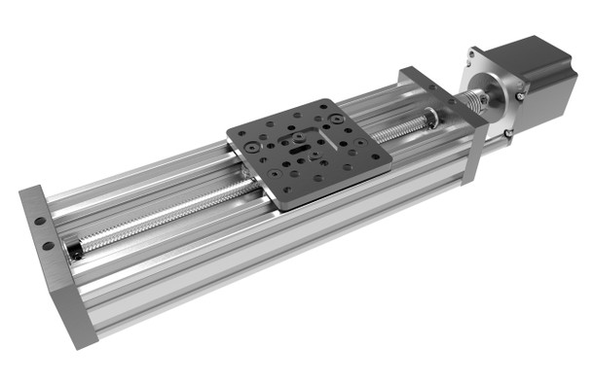

Figure 22 : Linear Actuator Bundle - OpenBuilds Part Store [16]

The gantry plate would be mounted to a vertical pedestal and the servo would drive the lead screw. A second servo would be mounted to control axial motion of the pedestal, allowing for access to the entire playing surface. Additionally, on the side opposite the radial motion servo, two smaller servos will be attached to control the motion of two vacuum tubes. The vacuum tubes would be used to pick up and manipulate cards.

#### **Venturi Vacuum Generator**

In contrast to Design Concept 1, in this design, a venturi block would be used to generate the vacuum necessary to manipulate the playing cards. This would require a source of compressed air to power suction and solenoid valves to turn it on and off. An air compressor would not be a part of this design or taken into account for cost, but would be a necessary pre-existing component for this build’s use.

#### **Power Supply**

This portion of the design will operate the same as above in Design Concept 1, section 5.1.1.3.

#### **Motors and Drivers**

This portion of the design will operate the same as above in Design Concept 1, section 5.1.1.4.

#### Flipping Mechanism

By utilizing two separate vacuum tubes and associated servo motors for control–briefly discussed in section 5.1.2.1 above–the playing cards can be manipulated without a separate mechanism. Vacuum tube 1 would pick up a card, then if instructed to flip by game logic, would begin rotating towards vacuum tube 2. This would be coordinated motion where at a certain point in 1’s rotation, 2 would begin rotating to grab onto the opposite face of the card. Vacuum in 2 would be initiated via solenoid, then vacuum in 1 cut off. This is a complex and sensitive operation, but still feasible.

#### Control Modules

This portion of the design will operate the same as above in Design Concept 1, section 5.1.1.6.

#### Computer Vision

Above the table, a camera will be positioned to have the full surface in view. This position will be fixed, so that the coordinates of the surface will be able to be predetermined. The cards will be placed in their assigned locations, which will be the same locations as the previous design concept. The camera will be able to read each of the cards at the same time, although the card will not be able to be read until it is face up. The camera, now that it has vision of the full playing surface instead of one card at a time, will be able to identify the robotic arm location. If the arm is in the wrong location, the system can now call an error and reset/correct the arm location. In the previous proposal, the camera has one function. In this proposal, the camera now can identify placement issues with the cards and the arm. The camera is connected directly to the Raspberry Pi.

#### Hardware Input/Output

The Raspberry Pi will interface with an Arduino Uno to communicate commands to the gantry based on the game logic. However, the Arduino will interface with two servos via a CNC shield to control gantry motion in the rθ-plane and two separate servos for rotation of the vacuum tubes.

The player will interface with the game through a touchscreen. This screen connected to the Raspberry Pi will provide output information to the user and when the user is prompted, it will read in user input from the screen.

### Software

#### Image Processing

The image processing will be very similar to the proposed design in the first design concept. The only difference is that the images of the cards will not be as clear. In the first design, the camera can and will only capture an image of a singular card. Now, the image received will be of the entire playing surface. The cards will need to be in specific locations according to whom they belong(player, dealer), so that the module will be able to accurately assign the card values to their matching cards in play. For example, if the camera can now see both the player’s cards and the dealer’s face up card, the module will need to know that the card at the dealer’s location belongs to the dealer and not the player.

The image processing will now also be able to handle the robotic arm. It will be much easier to identify, as the module will only look for cards and the arm. It will be able to tell if the arm is in the wrong location if the actual coordinates do not match the expected coordinates. This would require additional inputs from the game logic algorithm that would provide the image processing module with expected coordinates for the arm. This would increase runtime and complexity, but it would allow for more accurate arm control.

#### Game Logic

Game logic is dictated by the rules of blackjack and should not be affected by any of the changes made in Design Concept 2. It will operate as discussed in Design Concept 1, section 5.1.2.2.

#### Motor Control

This portion of the design will operate similarly to Design Concept 1, section 5.1.2.3. The primary difference would be the initial setup to ensure that GRBL interprets commands in the polar coordinate system and ensuring proper step size.

## Selected Design Concept

### Hardware

#### **Primary Mechanism**

The primary mechanism was chosen from Design Concept 1. There is a significantly larger pool of information on not only how to control the 3D printer-like gantry system, but varying types of control for this system. This will decrease prototyping time and allow for more refinement of the system controls.

Design Concept 2 was discarded due to time constraints and the complexity of creating a control schema for the type of system. Additionally, there were weight and balance concerns for the radial motion of the gantry. This is, in part, countered by having the gantry fixed and the servo components physically moving, but there are still concerns at the extremes of motion. Also, depending on actual construction, which would be affected by weight concerns, the motor torque required for angular motion could exceed the output of our motor constraints. Even if this were corrected utilizing gearing or some other method, it would likely reduce our speed such that it would be detrimental to section 3.1.1.3 system requirements–dealing time and game time.

#### **Vacuum Generation**

The vacuum pump method of generating vacuum was selected from Design Concept 1. This should simplify the design and control of the vacuum. This will also allow for a simpler and less obtrusive setup for prototyping.

A constraint of the venturi block method in Design Concept 2 is the requirement of a supply of compressed air by the consumer. This alone would likely make it an unattractive option for most interested individuals and families. However, in the case of industry sales, there is a concern that interested parties would not wish to undertake a renovation and associated costs on a trial product with unconfirmed interest from their clients.

#### **Power Supply**

The power supply from section 5.1.1.3 will be used. Depending on the other decisions made in this section, the current necessary for various other components–e.g. number of servos for the gantry design–may affect the exact design and will be accounted for in pcb and component design. This will be assessed in conjunction with the control modules design in section 5.3.5.

#### Motors and Drivers

The motors and drivers from section 5.1.1.4 will be used. Depending on the other decisions made in this section, the number of necessary motors and drivers may vary and will be assessed as necessary.

#### Flipping Mechanism

The flipping mechanism from Design Concept 1 was selected. Its operation is separate from the gantry and requires less complex movement and coordination. A single servo can be used to initiate card flipping and is independent from any other component.

Design Concept 2’s flipping mechanism requires multiple tuned actions to occur to operate properly. The vacuum tube’s servos must be distanced precisely and reliably turn towards and away from each other a minimum of eight times per game. The vacuum must also be started and stopped in a coordinated manner to ensure the card is not dropped in the exchange. This complexity adds to the necessary prototyping and optimization time, which will not be feasible or desired within this project’s constraints–the project deliverable milestone.

#### Control Modules

The control modules from section 5.1.1.6 will be used. Similar to section 5.3.1.3 and 4 above, depending on the other decisions made in this section, the exact design may be affected and will be accounted for in conjunction with the power supply design.

#### Computer Vision

The computer vision method of camera placement was selected from Design Concept 1. Although having additional inputs from the camera would be nice, it is not necessary for the requirements listed. Also, if the camera were above the table, the game logic would not know what the dealer’s hidden card is until it is revealed to the player. This would add additional processing time, as the game will not be able to produce an outcome(win/loss/push) until the new card is captured, processed, sent to the game logic algorithm, and the outcome is re-run. The first method allows the game to know what all of the cards in play are before the player does, which reduces in-game processing time. This may strain section 3.1.1.3 requirements.

#### Hardware Input/Output

The hardware input/output configuration was selected from Design Concept 1. Though it is not significantly different from Design Concept 2, other design decisions–e.g gantry design and flipping mechanism design–have hardware implications that are addressed in concept one and will need to be accounted for.

### Software

#### Image Processing

The image processing module will be designed based on the details in the first design concept. Using a camera under the table means that each image will be simply a singular playing card. This will reduce runtime, because the module will no longer need to identify which card belongs to whom, nor will it need to filter out the rest of the playing surface. The images will also be more clear, as the camera will be much closer to each card and in a more fixed position, which will lead to easier identification.

#### Game Logic

The game logic from section 5.1.2.2 will be used. No other design choices should affect this decision.

#### Motor Control

Based on the selected gantry design, the motor control scheme in section 5.2.2.3 would not work. Therefore, the motor control method in Concept Design 1, section 5.1.2.3 was selected.

# System Test and Verification

## Software Systems

### Game Logic Tests

Each component of the game logic software will be unit tested. These components of the software include the counting of cards, determination of a winner, determination of a winning wager, displaying to the output display, and sending output messages to the Arduino module. All unit tests will utilize a pass/fail assertion and it is assumed that if even a single unit test for a component fails, then the component as a whole is considered failing, i.e. all components must pass 100% of tests to be considered successfully implemented into the system. To measure a successful test or failure will be as follows:

* Counted values of cards will be compared to exact, expected sums of card values. A success is when the calculated sum equals the expected sum, such as King and 7 equals 17.
* Determined winners will be compared to predefined winning outcome combinations. A success is when the winners and losers output matches the provided rules, such as Dealer wins when Dealer has 20 and Player has 18.
* Winning or losing wagers will be compared to predefined payouts given a win or loss condition. A success is when the returned payout matches the correct value, such as total payout of 30 units when 15 units are initial wagered.
* The touchscreen display inputs will be compared to the corresponding visual output button that is pressed. A success is when the input that is read matches the button that is pressed, such as ‘hit’ is read when the hit button is pressed on the screen.
* The output controls messages will be compared to a predefined list of commands. A success is when the output message matches the desired command, such as ‘deal new card’

### Computer Vision Tests

The module in charge of image processing will be unit tested in order to confirm all requirements are met. The main requirements for this module are speed and accuracy. The module must be fast so that the card is processed by the time the next card is placed on the acrylic for scanning. The required processing time is under 5 seconds. The module must also be accurate so that the game logic operates correctly based on the cards in play. The required accuracy must be greater than 99.9%. If the cards are not accurately identified, the outcome of the game will be meaningless. These tests will include:

* Test 1: Test for Value: Base images for all 52 possible cards will be used as the input. Expected values for the value will be compared to the output of the module and a success will be counted if the value matches the expected. A one hundred percent success rate will be required for this test to pass.
* Test 2: Test for Suit: The suit of the card is not relevant to the outcome of blackjack, but the module is required to retrieve the suit as well. Base images for all 52 possible cards will be used as the input. Expected values for the suit will be compared to the output of the module and a success will be counted if the suit matches the expected. A one hundred percent success rate will be required for this test to pass.
* Test 3: Test for Accuracy: 100 iterations of tests 1 and 2 will be performed. Now, a success will be counted if both the suit and the value are correctly identified. Each card will be tested 100 times in a random order, for a total of 5200 chances. At least a 99.9% success rate will be required for this test to pass, so at least 5195 of the 5200 cards will need to be a success.
* Test 4: Test for Speed: Base images for all 52 possible cards will be used as the input. The runtime will be tracked and stored. Each run will need to have a runtime of less than 5 seconds for this test to be a success.
* Test 5: Test for Displacement: There exists the possibility that each image taken by the camera will not be identical to each other, as the card might be in a slightly different orientation. To account for this possibility, 5 images of each card will be taken, each one having the card shifted half on an inch in each direction. Each unique card will have a straight on image, a left-shifted image, a right-shifted image, an up-shifted image, and a down-shifted image. These images will all be tested in random order, and a 99.9% accuracy and less than 5 second runtime will be required for success.
* Test 6: Live Testing: For this test, cards will be placed manually on the acrylic, and the module will be tested in real time. All 52 cards will be placed, 5 seconds apart, and the each success will be counted if it is accurate and within 5 seconds. If all 52 cards are a success, then the test will be a success.

## Hardware Systems

### Power Supply Tests

Tests concerning the power supply are done to ensure that all aspects of voltage and current are known and regulated throughout the circuit. The AC-DC circuit, input impedance of the circuit, the regulation circuit, and the quiescent current draw will be the major focuses of the power supply tests. These tests together will help determine the voltage ripple in the DC output, the expected current draw of the circuit when operating on the power supply (full load), and a sense of what the total power of the circuit is.

The first test is for an AC-DC output voltage ripple of less than 2%. This will simply be done by using an oscilloscope with AC coupling to determine the level of the AC signal present in the DC signal, and then dividing that by the DC level at the output.

Another test for the project would be to determine the input impedance of the circuit. This will be done by measuring the voltage across the system, when put in series with a reasonably large load resistance. Using that, as well as the current flowing through the system, the impedance the source sees can be calculated.

A series of smaller tests to perform will be to test all rectifiers and regulators to ensure they are supplying the proper voltages and currents they are rated for. These tests will be fairly simple, as the only measurements to take are voltage and current measurements at the outputs of the regulation circuits.

Another test for the project is to determine the quiescent current draw of the circuit. This test will be very important as it will be a good metric in determining the available current for the motors after the circuit moves into a more active state. This can be determined by reading data sheets for the quiescent current draw of the individual components and measuring the current draw while all aspects of the circuit are connected to the power supply.

### Gantry System Tests

Physical requirements described in section 3.1.1 are primarily a function of the primary mechanism and gantry design. Therefore, at least one test for each requirement will be discussed below.

1. 3.1.1.1 Dimensions:

This test will be a simple physical measurement to ensure that clearances are appropriate. However, beyond this, as the prototype is assembled, game logic based movements will be tested and recorded to practically observe that clearances are sufficient.

1. 3.1.1.2 Card Movement:

Testing card movement will be of two parts.

First, repeatability of movements shall be verified by picking up a drawn card and moving it to its designated position–i.e. Player 1, card 1–a minimum of 5 times with records of variation in each movement. This data will be assembled into a table for every draw position for a minimum of three separate times to display variance over the course of play with a broad base of data to rely on.

Second, once the prototype is assembled, a minimum of three games in sequence will be played and after each initial deal, the position of each card relative to the ideal placement will be measured and recorded. The drift over the course of three games will be assessed in a minimum of three separate sessions

1. 3.1.1.3 Speed and Timing:

In conjunction with the second test for card movement above, the time of game completion will be measured. This measurement will be repeated for one, two and three players respectively. Additionally, the time at the completion of the deal will be marked for recording during each game for analysis. As a note, the benchmarks listed in section 3.1.1.3 are for *any* game, regardless of number of times hit. Therefore, normal time for completion of either task is anticipated to be significantly less than listed.

1. 3.1.1.4 Vacuum Generation:

Vacuum generation will be tested in stages. First, it needs to be established that available vacuum is capable of lifting a single card reliably. This will be determined on a ten trial basis of which none are allowed to fail. Next, once capable of gantry movement, the ability to maintain hold of a card under different velocity metrics will be tested. At least five separate velocities will be chosen, up to the maximum allowed by the gantry design. Each of the five velocities should undergo a minimum of five trials to ensure reliability and repeatability. Results will be recorded as either a success–suction with the card was maintained throughout movement–or failure–suction failed at approximately X% of full movement.

If suction cannot be maintained at high speed, then both dealing time and overall game time will be increased. As such, no single result in this section can be determined to be satisfactory without correlation with the speed and timing tests above. This test will be a tool used to analyze unsatisfactory speed and timing tests above for corrective action or optimization.

# Team

The team assigned to this project is composed of four individuals, two of which are electrical engineers and the other two of which are computer engineers. The electrical engineers will be focused on the physical, tangible components of the system with Kyle designing the system’s structure and movement while Nicholas designs the system’s power specifications and component connectivities. The computer engineers will design the less tangible parts of the system with Curtis designing the non-trivial algorithm as the game’s logic while Luca focuses on designing the image processing module of the system.

## Kyle Cullen

Kyle will be responsible for the gantry system design. The gantry system is required to be capable of moving anywhere within the playing area in the xy-plane to allow for card positioning and placement. It must also support a method of physically picking up playing cards and subsequently depositing them in a particular location–this will be accomplished utilizing a pneumatic suction via vacuum pump and may require a method of z-motion. It will also require choosing and implementing an appropriate gantry control scheme to allow for accurate xy-positioning. He is also responsible for interfacing game logic with gantry control in conjunction with Curtis.

### Skills learned in ECE coursework

ECE 1138 (Cyber Physical Systems) and ECE 1895 (Junior Design) combined and applied skills learned in many previous courses–ECE 0301, ECE 0302, ECE 1212, ECE 1673, etc. Kyle learned the underlying structure of microcontrollers and how to apply this knowledge to control. This required interfacing and processing various sensor inputs and adjusting outputs based on both finite state machine and PID controls schemes. It also gave him experience implementing algorithms to translate data into useful system and user feedback. Junior Design supplied him with significant experience on Arduino programming and interfacing with inputs and outputs, which will translate directly to gantry control using the Arduino and interfacing with the game logic.

### Skills learned outside ECE coursework

Kyle worked as an electrician for 5-6 years in both the Navy and industry. This provided significant troubleshooting experience and familiarity with mechanical and electrical system interfaces. He has also worked as a project engineer for the past two summers, which has provided him with extensive project management skills in design, teamwork and budgeting. Additionally, his last project this past year was upgrading the line control scheme at a manufacturing plant, including interfacing with new sensor configurations and tuning new drive systems. This experience will help with his current project goals.

In order to successfully execute this design:

* He will need to familiarize himself with different XY-gantry control schemes and choose the method that will use based on pros and cons and project constraints.
* After the control scheme is decided upon, he will have to decide on the implementation method–whether to use an existing software method such as GRBL, or to program a method specifically for this project.
* This will require him to learn different servo control methods for the hardware to be used and understand the limitations of each.

## Nicholas Lowe

Nicholas will be responsible for the creation of the power supply and the development of the PCB connecting the various modules developed by the other members of the group. His other roles include supporting Kyle’s motor controls and operations as well as creating various parts and enclosures for certain modules including an enclosure for the power supply as well as custom made parts for the gantry bearings. He will also be responsible for aesthetic aspects of the design including lights and sounds of the dealer given that the minimum standard for project completion has been achieved.

The skills that make him suited to these roles include his 2 rotations spent working with power management and monitoring systems at Eaton Corporation, a single semester research project under the University of Pittsburgh’s Material Science department in which he developed both an LED driving circuit and performed preliminary tests on a current transformer harvesting circuit for an optical interrogator, and his personal knowledge of CAD design from Junior Design Fundamentals as well as prior experiences with AutoCAD.

### Skills learned in ECE coursework

The skills that he will implement from prior ECE courses include knowledge of AC-DC rectifier design, DC regulation, and PCB design. The AC-DC rectifier design takes aspects of ECE 102’s use of non-linear characteristics of components such as diodes and transistors alongside ECE 1701’s focus on high voltage/current design elements such as transformers and the considerations that coincide with them. These characteristics of these components come together to create the basis for the AC step down, rectifier, and regulation circuits that comprise a typical power supply.

His skills in PCB design came from his time in Junior Design Fundamentals. The course gave me knowledge of PCB design considerations such as how trace width affects the reliability of the PCB, what steps should be taken to reduce unintentional capacitances in the circuit design, and how to mitigate unintentional antennas in board traces.

In addition to the aforementioned courses, aspects of other courses like Power Electronics Conversion Theory, Analog and Digital Filter Design, Electromagnetics and Electric Machinery may be pertinent to his secondary roles in the project given enough time to move on to more aesthetic aspects of the design.

### Skills learned outside ECE coursework

Much of the major research that he will be doing during this project will be focused on motor and motor control systems. While he has a pretty good handle on most of the aforementioned aspects of my roles, motor operation and powering has never been a thing he has ever dealt with at length. As a result, the general operation of stepper motors as well as their power requirements are foreign to him. He has already had ample opportunities to look through various videos and text concerning stepper motor fundamentals and the means by which they operate. In looking into them already, He has already determined the properties that allow them to work and am already familiar with some of the components used for their operation (H-Bridge inverters, current limiters, etc.).

Another aspect of the project he will need to do research on is the optimal usage of the vacuum pump included in our chosen design. More specifically, he would need to get a better grasp of the mechanics behind the pumps suction ability, and determine the best means of powering in such that the pump will be able to suck the cards up as intended

* Suction with vacuum pump
* stepper motor operation and control

## Curtis Maher

Curtis will be primarily responsible for developing the non-trivial algorithm that is the game logic. This will essentially be core to the system as it must handle inputs from several other modules and then through its functionality, it must disperse outputs to several different modules. Alternate roles within the team will be to assist in the implementation of the computer vision module with Luca and to assist in the development of the motor control software with Kyle.

### Skills learned in ECE coursework

Several classes from the ECE department have contributed to Curtis’s knowledge that will benefit him in designing and developing his portion of the project. The first class is ECE 1140 as that class gave him a clear understanding of how to explicitly design and develop a software system from the beginning, including all the requirements and documentation, through to the end, including a functioning and thoroughly tested prototype. Another takeaway from that class is iterative development, which having and understanding of will give him a good pace to complete project milestones before predefined deadlines.

The next class that will benefit Curtis throughout this project is ECE 0302, as that class dealt with understanding and developing algorithms. This will prove useful as he will be designing the algorithm to implement the game logic of Blackjack. While the rules of Blackjack will not be newly developed, he will have to implement the functionality of the game through a thought-out program.

Another class that will prove beneficial is ECE 1175. The topics learned from this class will help him in working with a Raspberry Pi, interfacing with embedded system devices, and handling I/O devices and the interrupts that typically come along with these devices. As Curtis is currently taking this course, he will have to do my own research using outside resources alongside looking ahead at future lessons and future readings from the provided text to make the topics more applicable sooner rather than later.

### Skills learned outside ECE coursework

Outside of coursework, Curtis has worked with the Python programming language in a side project of developing a software bot. This project included concepts such as object-oriented programming as well as interrupt handling that will relate to necessary requirements of developing software in this project. Additionally, this project was iteratively developed and included many testing steps which will prove to be very beneficial when developing the software portion of the system and ensuring that all components of it perform as accurately as expected.

Another skill that Curtis has picked up overtime is a good understanding of the game of Blackjack. This may seem silly, but this knowledge will help to be very advantageous as he will not have to learn the rules and behind-the-scenes logic of a new game. This comfortability will make development substantially easier, allowing for more time to optimize the program and test it thoroughly.

## Luca Mahoney

Luca will be responsible for the image processing module of this project. Luca will develop a module that is responsible for receiving an image of a playing card and producing the proper value. The suit may also be identified, yet is irrelevant for the outcome of the game. This module will be connected to the game algorithm module, because the algorithm is dependent on which cards are dealt. Luca will also be required to setup and troubleshoot the camera, which will be connected to the raspberry pi.

### Skills learned in ECE coursework

There are several courses that prepared Luca with the skills needed for this project. ECE1175 provided him with his knowledge on the raspberry pi, as all of the projects in that course utilized the pi. This will allow him to run programs and modules with ease. He also learned about interfacing with microcontrollers in this course, which he will need to use to forward the output of my module to the module that Curtis is designing.

Another course that Luca learned valuable skills in was ECE1140. This course gave him the majority of his python knowledge, as his group wrote their train simulation fully in python. This prior experience in interfacing and communicating with other modules in python will be valuable, as Curtis and Luca will need to have their two modules communicating, and they will both be written in python. This course also taught him the requirements of software engineering and the standards that he will need to follow to develop proper code. He also learned valuable teamwork and communication skills vital for a project of this scope.

He also will pull information from ECE1145, which further reiterated those skills and coding practices that were introduced in ECE1140. This course also provided him with experience in game design, which he can use in the creative aspect of the project’s overall customer experience. Both ECE1140 and 1145 focus on the customer, and designing interfaces and modules that are comprehensible and enjoyable.

He will use his knowledge gained from ECE0202 in using microcontrollers to interface with the camera for his module. This course focused on receiving inputs and processing them, which he will need to do for the image processing. Luca will also use his knowledge on data structures learned from ECE302 and ECE1170 to create a code base that efficiently stores data.

He will use the knowledge gained from ECE1180, where he made several large scale simulations and games in python, to properly structure methods and classes that he will need to make for my module.

Finally, Luca will use the skills gained in ECE1895, where he gained hands-on experience in prototyping. This course taught him the importance of getting a functioning prototype, and he learned how to interface an arduino, which will be used by the team as they communicate from the pi to the arduino for gantry controls.

### Skills learned outside ECE coursework

For this project, Luca will need skills in computer vision and image processing. He did not take ECE1390, so he will use the skills learned from completing several online courses on computer vision. These resources were provided to him by Dr. Ahmed Dallal, the professor for ECE1390, so they should be sufficient for this project. If not, he will need to obtain further knowledge on this topic, likely through Dr. Dallal, Dr. Mai Abdelhakim, or the team’s industry coaches.

He will also use the knowledge on card games, gambling, and the casino industry that he has acquired in his lifetime to collaborate on the user experience to provide the most engaging experience for the customers.

# Schedule and Budget Plan

## Project Schedule

**8.1.1 Week 1 (Monday October 3rd):**

* Kyle: Fully assembled and aligned gantry ready to begin testing and receive servo commanded movements.
* Nicholas: Testing rectifier and loaded voltage levels through a test load.
* Curtis: A skeleton of the program will be completed. Card values should be correctly understood. Given two competitors, a winner can be determined based on a hand.
* Luca: By this date, Luca will have completed auxiliary computer vision training and began development of the card processing module.

**8.1.2 Week 2 (Monday October 10th):**

**8.1.2.1: Checkoff #1 - Wednesday October 12th:**

**Group Expectations for Checkoff:**

1. Demonstrate a mobile gantry utilizing commands input from computer.
2. Demonstrate voltage and current levels of AC-DC power supply.
3. Demonstrating a game of blackjack using the raspberry pi terminal.
4. Demonstrate a functioning image processing module using test images.
5. Demonstrate suction capable of lifting a single playing card.

* Kyle: Full XY gantry movement possible using g commands directly from the computer interface. Vacuum tube viability verified.
* Nicholas: Voltage and current levels for AC-DC power supply will be obtained. Will begin work on determining input impedance of connected components as well as PCB for full circuit connections.
* Curtis: The program will be able to simulate a functional game between a single player and the dealer. Inputs of hit, stand, and basic wagering shall be read and interpreted. A winning or losing result should be accurately determined 100% of the time.
* Luca: By this date, Luca will have completed the first iteration of his module and will be able to use dummy images as inputs to receive the proper output.

**8.1.3 Week 3 (Monday October 17th):**

* Kyle: Full, repeatable XY gantry movement possible using precoded uploaded commands.
* Nicholas: Overvoltage protection testing.
* Curtis: More features, such as splitting, doubling down, and insurance wagers will be added.
* Luca: By this date, Luca will have created his database of possible images for his module to scan through using images taken from the camera. He will begin testing his module. He will also 3-D print a holder for the camera.

**8.1.4 Week 4 (Monday October 24th):**

**8.1.4.1: Midterm Presentation - Wednesday October 26th:**

**Group Expectations for Presentation:**

1. Demonstrate the gantry is capable of moving playing cards to predetermined points in the XY-plane.
2. Demonstrate power supply is giving reasonable voltage and current values to parts of the circuit.
3. Demonstrate a game with multiple players playing with random cards. Demonstrate a game with multiple players with forced starting hands to show additional features.
4. Demonstrate taking an image with the camera and producing the proper value.

* Kyle: Z-movement for vacuum tube integrated with gantry movement. Gantry capable of lifting and moving cards utilizing hard coded movements.
* Nicholas:Determine different input impedance levels of circuit (motor dependent) and tune AC-DC rectifier circuit to match the expected impedance.
* Curtis: Multiple players can be handled and a full game of varying number of players will be simulated with a correct determination of the dealer winning or losing being accurate 100% of the time.
* Luca: By this date, Luca will have debugged his code and implemented camera functionality. He will ensure that his algorithm is producing accurate results at least 90% of the time and takes less than 10 seconds from image to result.

**8.1.5 Week 5 (Monday October 31st):**

* Kyle: Draft versions of g-code will be prepared for various gantry motions. This will begin testing for integration with a dummy version of Curtis’s game logic code.
* Nicholas: Full circuit current draw tests. Continue testing and optimizing voltage and current levels throughout the circuit. Finalize PCB design. Begin working on aesthetic design with active filters for a speaker circuit.
* Curtis: The game logic program will be able to interface with the external Arduino. Commands will be sent and anything received will be interpreted.
* Luca: By this date, Luca will continue to iterate with his module to reduce run time to less than 5 seconds and increase the accuracy to at least 95%. He will be testing with the card on the acrylic surface.

**8.1.6 Week 6 (Monday November 7th):**

* Kyle: All necessary movements will be coded and ready for deployment based on game logic commands. This is also where tolerances will begin to be actively tested to ensure speed and placement accuracy requirements are being met.
* Nicholas: Assist Kyle with g-code for gantry motions, continue on aesthetic design with lights
* Curtis: The
* Luca: By this date, Luca will have a fully functioning module that is able to communicate the card value to the game algorithm module. He will continue to test/debug. He will continue to assist in the prototype implementation.

**8.1.7 Week 7 (Monday November 14th):**

* Kyle: Focus on flipping mechanism and execution. Continue refinement of motion to optimize speed and accuracy. At this point, limit switches may prove necessary for calibration between games.
* Nicholas: Buffer time for fixing any issues involving PCB/power supply. Assist Kyle with motor speed and accuracy adjustments. Continue on aesthetic design.
* Curtis: The game logic will be able to utilize an external touchscreen display. A generic output should be correctly displayed and inputs should be correctly read at least 50% of the time.
* Luca: By this date, Luca will continue to assist in the prototype implementation and testing.

**8.1.8 Week 8 (Monday November 21st) THANKSGIVING BREAK:**

* Group: The group will be done with the prototype by this date.
* Kyle: Ensure proper coordination with Curtis’s game logic code and assist in debugging, testing and integration. Verify project standards are met and recorded in accordance with section 6.2.2 test procedures.
* Nicholas: Ensure that final PCB is operational, with voltages and currents matching expectations through testing, and integrate aesthetic design elements into prototype
* Curtis: All interfacing with external modules will be implemented correctly and should function as expected 100% of the time.
* Luca: Continue debugging/testing/reintegrating. Work on the display and the presentation material

**8.1.9 Week 9 (Monday November 28th):**

**8.1.9.1: Checkoff #2 - Wednesday November 30th:**

**Group Expectations for Checkoff 2:**

1. Demonstrate functioning prototype.

* Kyle: Continue to assist with finishing touches/optimization. Work on presentation and report.
* Nicholas: Buffer time for fixing any issues involving PCB/power supply. Continue integrating aesthetic design elements into the prototype. Work on presentation material.
* Curtis: The game logic software will be going through intensive unit testing.
* Luca: Continue debugging/testing/reintegrating. Work on the display and the presentation material

**8.1.10 Week 10 (Monday December 5th):**

* Kyle: Close out final presentation and prepare with team.
* Nicholas: Begin work on final document.
* Curtis: Continue unit testing. Verify all inputs are read correctly 100% of the time. Verify all outputs are sent out correctly 100% of the time. Verify logic creates an output from an input correctly 100% of the time.
* Luca: This week, Luca will work on the final document, and prepare with his team for the final presentation and the expo.

**8.1.10.1: Final Presentation - Wednesday December 7th:**

**Group Expectations for Presentation**

**8.1.11 Week 11 (Monday December 12th):**

* Kyle: Continue work on the final document.
* Nicholas: Continue work on the final document
* Curtis: The main Python program for the system’s game will be able to run on the Pi as if flashed to memory as opposed to manually configuring it upon powering on.
* Luca: Assist in the final document writing

**8.1.11.1: Final Document Due: Friday December 16th**

## Project Budget

| **No.** | **Description** | **Quantity** | **Cost** | **Cost/Item** | **Used** | **Actual Cost** |
| --- | --- | --- | --- | --- | --- | --- |
| 1 | Vgoohobby Metal Shocks | 4 | 19.07 | 4.77 | 1 | 4.77 |
| 2 | 3Dman Toothless Bore 5mm Belt Idler Pulley | 10 | 12.71 | 1.27 | 2 | 2.54 |
| 3 | Zeelo Timing Belt/8-20 Teeth Pulleys | 1 | 15.89 | 15.89 | 1 | 15.89 |
| 4 | IdeaFormer V-Slot Gantry Plate w/ Wheels | 1 | 11.99 | 11.99 | 1 | 11.99 |
| 5 | SBR RAIL Linear Rail/Linear Bearings | 1 | 18.29 | 18.29 | 1 | 18.29 |
| 6 | V-Slot 2020 Linear Rail 500mm | 12 | 86.87 | 7.24 | 12 | 86.87 |
| 7 | T-Slot Accessory Kit | 230 | 20.99 | 0.09 | 50 | 4.56 |
| 8 | 3D Printer Controller Kit | 1 | 58.53 | 58.53 | 1 | 58.53 |
| 9 | Arducam 5MP Camera for Raspberry Pi | 1 | 10.59 | 10.59 | 1 | 10.59 |
| 10 | Vacuum Pump - FIT0801 | 1 | 5.50 | 5.50 | 1 | 5.50 |
| 11 | Rectifier | 1 | 1.40 | 1.40 | 1 | 1.40 |
|  |  |  | 308.42 |  |  | 230.93 |

Table 1: Fund Allocation

All of the listed items (except 9 and 11) are being used for construction and operation of the entire gantry system and associated structure. Item 9 is necessary for image processing. This should be nearly everything required for this project. The only outstanding item is a PCB for the power supply which is what item 11 is to be used for.

## Minimum Standard for Project Completion

At minimum, our design will be capable of completing a game of blackjack against one player with increased time constraints–less than 5 minutes–and some of the automated features. The design would be implemented without the feature of betting, simply determining if the user won or lost. The minimum design would also be implemented without a flipping mechanism. Instead, the user would simply flip the cards themselves as necessary within bounds marked on the playing surface. The minimum image processing design will only retrieve the value of each card, instead of both the value and the suit.

In terms of design requirements, four will be affected by the minimum standard of completion. The dimensions requirement of 3.1.1.1, “be able to…accommodate three players,” would not apply. Section 3.1.1.3, speed and timing, expanded to five minutes, a time where a player might begin walking away from the table in the middle of a hand. Section 3.1.3.3, betting, requirements and the card suit identification requirement in image processing, section 3.1.3.4, would also not apply in this scenario.

In terms of the selected design concept, the majority of hardware must be executed as discussed. This includes sections 5.3.1.1-4, and 7. Without some features, motors and drivers, the control modules and hardware inputs/outputs would be reduced in complexity (sections 5.3.1.4, 6 and 8). The primary hardware change in a minimum standard would be player initiated flipping, thereby making the flipping mechanism from section 5.3.1.5 unnecessary. In software, motor control would still need to be executed from section 5.3.2.3, and within section 3.1.1.2 limits. Sections 5.3.2.1 and 2–image processing and game logic–would be reduced in complexity and usefulness. Image processing by removing suit identification and game logic by eliminating betting.

## Final Demonstration

You will be required to demonstrate your working prototype to the instructors, and show them the data from your testing. In this section please describe what you will demonstrate, and what test results you expect to show. This is quite different from the minimum standard for completion, but rather all of the features on which you expect to be graded and evaluated.

For the final demonstration, several rounds of Blackjack will be played and demonstrated. First, the user will select for the game to begin. One player will play, so that will be inputted for the game to begin. The user will select the amount of currency they would like to “deposit” and they will select their “bet”. Once finalized, the dealing will begin. The first card, which is going to the player, will be picked up by the vacuum tube and moved to the acrylic. The camera will take an image of the card, and the card will be flipped by the flipping mechanism detailed in section 5.3.1.5. The card will then be picked up by the vacuum tube and move to its designated location for player 1. This process will repeat again, this time for the dealer’s first card. This card will be placed in the first of the dealer’s two designated card locations. Next, the player will receive their second card, and then again for the dealer’s second card. The dealer’s second card will not be flipped; this card will instead be picked up directly from the acrylic and placed face down in the second of the dealer’s designated card locations. The image processing module will receive each of these images as they occur and output each card to the game logic algorithm. The values and suits of these cards will stored in this module.

Now, set-up will be demonstrated as complete, as each of the 4 cards will be in their appropriate positions, and the display will prompt the user for an input. The user can either hit, which will trigger the gantry system to deal another card to the user, or they can stand, which will end the user’s actions. To demonstrate the functionality of the game, a hit will be selected, and the user will receive an additional card. The user will then end their turn, which will prompt the gantry system to position itself over the dealer’s second card. This card will be moved to the flipping mechanism, where the card will be flipped and revealed. As this occurs, the game algorithm will determine the outcome of the hand. If the user wins, the display will show a success graphic and the amount of “currency” they won. If the user loses, the display will show a losing graphic and the amount of “currency” they bet will be discarded from their total. If the user ties with the dealer, a graphic will display to inform the user, and their “currency” will be unaffected.

Regardless of the outcome of the game, once complete the gantry system will move to each card to pick up and move to the discard pile. Once all cards are properly discarded, the game will reset its game state.

The game will be demonstrated several times. With one player, each outcome, a win, loss, and draw, will be demonstrated, and the accuracy will be confirmed by the hosts. The runtime will be kept, from start to finish, and will be displayed. Each run shall meet the timing requirements set in section 3.1.1.3, which is under 3 minutes for a 1 player game.

The game will also be demonstrated with two players. This will be run once, and the accuracy of the game outcome will be demonstrated and the runtime will be less than 4 minutes.

# References

[1] Miller, A. (2021, December 17). How does a casino make money from Blackjack? Retrieved from Gamle Online: https://www.gambleonline.co/blog/how-does-a-casino-make-money-from-blackjack/#:~:text=So%20a%20casino%20would%20expect,your%20%24100%20bet%20on%20average

[2] ZipRecruiter. (N/A, N/A N/A). What is the Average Casino Dealer Salary by State. Retrieved from ZipRecruiter web site: https://www.ziprecruiter.com/Salaries/What-Is-the-Average-Casino-Dealer-Salary-by-State

[3] Golden Acorn Casino. (2018, October 29). Casino Tipping Etiquette Guide. Retrieved from Golden Acorn Casino Travel Center web site: <https://www.goldenacorncasino.com/blog/gaming/casino-tipping-etiquette-guide/#:~:text=In%20general%2C%20you%20should%20expect,for%20a%20particularly%20long%20time>

[4] PA Department of Labor and Industry. (2022, N/A N/A). General Wage and Hour Questions. Retrieved from PA Department of Labor and Industry web site: <https://www.dli.pa.gov/Individuals/Labor-Management-Relations/llc/Pages/Wage-FAQs.aspx>

[5] Krog, K. (2022, September 1). Playing Online Blackjack at Live Casinos: A Comprehensive Guide. Retrieved from Betters Insider: <https://www.bettorsinsider.com/casino/2022/09/01/playing-online-blackjack-at-live-casinos-a-comprehensive-guide>

[6] Sztein, A. (2013, February 24). This Robot Dealer Can Read Cards and Won't Hit on 21. Retrieved from TrendHunter: <https://www.trendhunter.com/trends/robot-dealer>

[7] Motoman Robots. Robots Done Right. (n.d.). Retrieved September 30, 2022, from https://robotsdoneright.com/Motoman-robots.html

[8] Penn National Gaming, Inc. (2021, September 29). Blackjack Rules and Guidelines. Retrieved from Hollywood Meadows: <https://www.hollywoodmeadows.com/-/media/png/east/meadows/pdfs/table-games/gamingguiderebrands2022/mdpb-apr22-gaming-guide-rebrand-file-resend-digital-col-84418-blackjack-min.pdf>

[9] Federal Communications Commisison. (N/A, N/A N/A). Equipment Authorization-RF Device. Retrieved from FCC: <https://www.fcc.gov/oet/ea/rfdevice#:~:text=The%20FCC%20regulates%20radio%20frequency,9%20kHz%20to%203000%20GHz>

[10] Ocupational Safety and Health Administration. (2008, October 29). By Standard Number/1910.303-General. Retrieved from OSHA web site: <https://www.osha.gov/laws-regs/regulations/standardnumber/1910/1910.303>

[11] Hammond Manufacturing. (N/A, N/A N/A). Low Voltage, Filament High Current, Chassis Mount - 125 VA to 440 VA. Retrieved from Hammond Manufacturing web site: <https://www.hammfg.com/electronics/transformers/power/165>

[12] Vasquez, J. (2014, May N/A). CoreXY. Retrieved from Double Jump Electric web site: <http://www.doublejumpelectric.com/projects/core_xy/2014-07-15-core_xy/>

[13] Rani, U. (2020, August 19). Ripple Factor of L-section Filter. Retrieved from Youtube web site: <https://www.youtube.com/watch?v=wDdHWcPHm6A>

[14] N/A. (n.d.). AcetoFive. Wikimedia.org. N/A, N/A.

[15] Dejan. (N/A, N/A N/A). G-code Explained | List of Most Important G-code Commands. Retrieved from How to Mechatronics Website: <https://howtomechatronics.com/tutorials/g-code-explained-list-of-most-important-g-code-commands/>

[16] C-BEAM® linear actuator bundle. OpenBuilds Part Store. (n.d.). Retrieved September 30, 2022, from https://openbuildspartstore.com/c-beam-linear-actuator-bundle/?sku=995-Bundle&amp;gclid=CjwKCAjwp9qZBhBkEiwAsYFsbzN56A5mzjgf9VDrDf03D2nTnK0K0kWv7D2KgLrUDnmbTf_ar4hY_hoCkW8QAvD_BwE